Cook Islands Cable Station
Technical Specifications & Requirements
Content

1. INTRODUCTION 3
2. DESIGN LIFE & WARRANTY 7
3. DESIGN APPROACH 8
4. FUNCTIONAL DESIGN 11
5. CIVIL AND STRUCTURAL WORKS 17
6. M&E SERVICES 19
7. COMMISSIONING AND PROVIVIONAL ACCEPTANCE 31
8. ABBREVIATIONS 32
APPENDICES 33

INTRODUCTION

Purpose
    - This document defines the technical and performance requirements for 2 submarine telecommunications Cable Landing Station (CLS) in Cook Islands. Such CLSs are used to host telecommunication equipment, and associated services, required to have a successful telecommunication system.
    - These CLSs are to be delivered in Rarotonga (Cook Islands) and Aitutaki (Cook Islands) and will be connected in the MANATUA Cable system (Samoa – Niue – Cook Island– Tahiti).

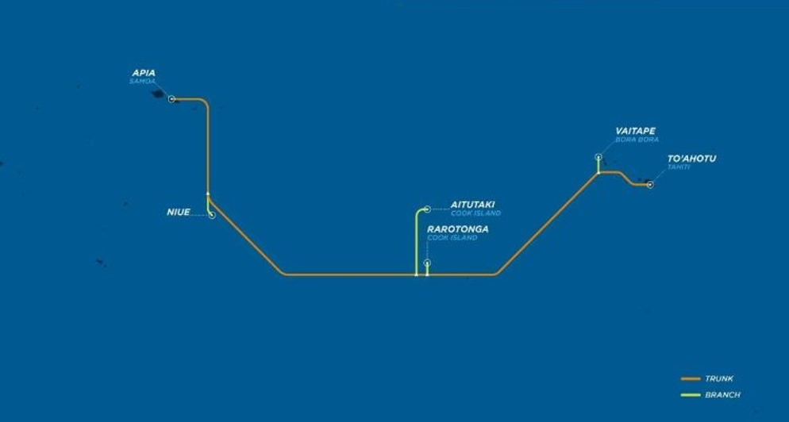

Scope of Work
    - The Cook Islands Cable Landing Station sites information are defined in APPENDIX 1.
    - The Purchaser is interested in obtaining a turnkey design, provision and construction proposal for the works/services described herein.
    - The purchaser has a preference for integrated modular construction techniques but is considering alternatives (hard construction, other).
    - Each station will be designed to support a total of one unpowered systems and associated services at its final transmission equipment configuration.
    - The scope of work as described in this document covers the supply and installation of the Cable Landing Station building with design, engineering, procurement and construction of the Cable Landing Station as per the New-Zealand Building Code and/or the applicable international building codes in accordance with these general requirements (when not covered within the New-Zealand Building codes).
    - However, this shall include compliance with design codes and shall include construction practices compliant with the appropriate cyclone rating (min Category 5), Zone 4 seismic rating or better and protection from inundation by water (better than 1 in 100-hundred-year flood levels) including by tsunami.
    - The CLS building and associated services, need to be designed to support heavy rain environment, and highly corrosive salt water laden environment.
    - All electrical equipment/works shall comply with the applicable local codes or latest AS/NZ 3000 whichever is applicable. A lightning protection is also required to protect the building and all associated services.
    - Commissioning and Acceptance of the CLS facility per these requirements, and handover of all the above works to Avaroa Cable Limited (ACL).
    - Provision of training in operation of the systems provided for all services provided (AirCon, Building Management System, etc ..) the contractor to provide syllabus for such training.
    - Provision of all documentation, design drawings, construction manuals, user manuals, administrative manuals, maintenance manuals/calendars, and final as built drawings.
    - Project management services;
    - The following components are described in either general or specific detail:
      - design life
      - functional design
      - civil and structural works
      - M&E services
    - The CLSs are required to operate without interruption through all reasonably anticipated inclement acts of nature and failure of the external power supply with 7 days’ autonomy for the back-up systems (in option for Aitutaki).
    - The CLSs are to be an unmanned 24 x 7 facility. All equipment should be remotely managed, additionally the contractor will provide a Building Management System, able to control and supervise all services (commercial energy failure, full Diesel Generator System (DGS; in option for Aitutaki) (alarms, activity...), fuel tank levels (daily and external), ATS switching positions, fire system detection and fire system extinguisher, Access system and intrusion alarm, CCTV (option), air conditioning, AC and DC equipment’s and breakers position (PDP), temperature and humidity,…). The BMS system will have the possibility to be remotely managed, the contractor to indicated requirements of the connection line for the remote control.
    - The contractor will provide maintenance items for all services for a duration of 5 years (DGS items, AirCon,..) the contractor to list all maintenance items provided.
    - Option 1: The Contractor to provide and install the DGS system in Aitutaki for the CLS, this option should also include all related maintenance items required for the first 5 years of operation.
    - Option 2: The contractor to provide and install CCTV/PTZ cameras for the inside of the CLSs and the outside of the CLSs. The CCTV system should be able to records in a cycle of 1 month, the PTZ Cameras should be able to work in dark conditions, the CCTV should be controllable and accessible remotely. The outside PTZ Cameras should be proof
    - Option 3: The contractor to design, build, and provide a dedicated CLS earth ground < 10 ohms (also called Station earth), ended on a copper bar within the CLS. The contractor to design, build and provided a lighting protection system sized according to local requirements.
    - Option 4: the contractor to provide a CLS with double of its base specifications (surface, power equipment, aircon, …). (for both sites)
    - Option 5: 1 (one) year after Provisional Acceptance date (Final Acceptance date), Contractor’s personnel to perform the Final
Acceptance testing.
    - Option 6: The contractor to consider an extra area within the equipment room to host 6/8 persons (table and chairs). This area would be separated from the equipment room by a removable wall and it will be noise isolated. Lights, power sockets, RJ45 sockets to be considered. If possible, specifics air vent could be installed on the removable wall to permit fresh air to flow to this extra area. The Contractor to indicate impact on fire system detection/extinguisher and solutions. Alternate solution could be proposed to the Purchaser.
    - If options 3 is not exercised, the Contractor will be required to work closely with the Local Civil Engineering team/local contractor, in particular with regard to the design and construction of the said option(s), to make sure the interconnection between the works will be successful.

List of all requested options:

Option Number | Description | Paragraph.
Option 1 | DGS (including CLS size extension and required update of services) for Aitutaki site
Option 2 | CCVT/PTZ system for inside and outside of the CLS
Option 3 | Station earth < 10 ohms and lightning surge system
Option 4 | Supply of a CLS with double of its base capacity (surface, power, Aircon, ..)
Option 5 | Contractor’s participation for Final Acceptance testing
Option 6 | Extra area for meeting room

Civil Works
    - A separate tender will be called for the supply of Local Civil Engineering Works; however, it is requested the contractor to quote as an Option the following paragraph (b) (iii).
    - The following works can be assumed to be supplied by others:
      - Local Civil engineering for the cable landing station (“CLS”) including demolition of any existing structures on the site and removal of all waste (if applicable). This includes construction of any concrete slabs or footings needed for the CLS construction method chosen and the man holes and ducts inside the building line required for the Fronthaul and Backhaul ducts;
      - All required civil works inside the building line of the cable landing station site is part of a separate civils scope of work. This includes the landward end of the front haul duct and the seaward end of the backhaul ducts that terminate in the CLS. This also includes the cable manholes for the main front haul submarine cable and backhaul cables.
      - All required design, civil works, procurement, construction, installation to have a station earth (< 10 ohms), and a lightning protection system for the CLS and its services.
      - Construction of the front haul duct from the CLS building line to the new beach manhole;
      - Construction of the Beach Manhole (BMH);
      - Construction of diverse backhaul ducts from the CLS building line to a point of presence.
      - Security fences and parking areas per local council approvals;
      - Local council permits, consents (including environmental) approvals, including construction approvals for the work including (if selected) the selected options.

DESIGN LIFE & WARRANTY

- The CLS shall have a design life of at least twenty-five years.
- The CLS key systems must be capable of being maintained or repaired without interruption to service of the submarine cables. Contractor to explain in their design how this is achieved.
- The CLS key systems must be capable of concurrent expansion without interruption to or putting at risk the ongoing operation of the facility.
- The CLS and associated services would be covered with a 5 years Warranty.

DESIGN APPROACH

General Requirements
    - In developing the design and price, the Contractor must consider those designs, materials and building services that deliver a low cost but fit for purpose structure.
    - The final design to be submitted for Purchaser’s assessment and approval must incorporate the requirements defined in this specification however the Purchaser is willing to review alternative suggestions from the Contractor that further reduce costs.
    - Contractor is responsible for providing all engineering drawings, documentation for permits and construction works.
    - Contractor is responsible for providing all engineering drawings for Purchaser approval and signoff under control of a documentation controller and registered on a documentation master list, prior to the respective construction works commencing. Such drawings include those for the CLS site works and CLS construction.

Environment Management Plan
    - When required, the Contractor shall prepare a site environmental management plan (EMP) detailing hazardous substance management, and as appropriate soil and water control, site rehabilitation, waste collection and removal, dust suppression and noise abatement.
    - The EMP will be required to conform to all environmental conditions and approvals applied to the project by the conditions of development consent and the requirements of the relevant statutory authorities.

Occupational Health and Safety
    - The design and construction of the CLS is to provide the Purchaser with a working environment in conformity with all relevant Occupational Health and Safety requirements, guidelines and Legislation.
    - The design of mechanical and electrical systems is to comply with the requirements of these laws and regulations.

Electromagnetic Compatibility
    - The communication equipment to be installed in the building is sensitive to electromagnetic interference.
    - All mechanical and electrical systems and plant designed and installed by the Contractor shall comply with the relevant National or International Standards and or such requirements as may be stipulated by the authority having jurisdiction with regard to electromagnetic compatibility (emission and immunity).

Earthing
The earthing of the building, systems and plant is a specific requirement detailed in the Electrical section of this document.

Corrosion Protection
The CLS will be exposed to salty air and is thus in a highly corrosive environment. The Contractor shall describe in their proposal the measures, materials used in the CLS building itself and the main subsystems (including air-conditioning condensers for example) resistance to a saltwater environment noting the design life requirements at Section 2.

Compliance to Standards
    - All work (design and construction) shall be carried out in accordance with relevant National Standards and other relevant standards as may be applicable or required by all authorities having jurisdiction over the work, including but not limited to:
      - New Zealand Building Code
      - Fire Department
      - Public Utilities supply authorities (electricity, water, sewerage and communications)
      - Electric Wiring rules (AS/NZ 3000)
      - Health and Safety Act
      - National Environmental Agency (NEA)

Construction Certificate
The Contractor at the final handover will be required to provide producer statements (required under the New Zealand Building Code) certifying the works have been constructed in accordance with the documentation and all applicable building code regulations.

Testing and Acceptance
The Contractor shall propose factory acceptance testing (“FAT”) if applicable to their offer. The Purchasers reserve the right to attend the Contractor’s site during manufacture to review progress and conduct FAT prior to shipping.

FUNCTIONAL DESIGN

General
    - Key parameters of the CLSs are shown in Table 1 below:
Item | Description | Comment | Paragraph Number
1 | Manning | Unmanned
2 | IT Floor space CLS (PFE, SLTE and backhaul LTE) for one cable system | 15 sqm for equipment/racks are required from the telecom supplier for only its equipment’s.  Additional sqm for the DGS room, AirCon, AC plant, DC plant, ... to be designed/defined by the Contractor | Appendix 1
3 | IT Design Load | Refer to ANNEX 1 | 6.4.7
 | Maximum IT load for one cable system. |  | 6.4.8
4 | Site Design Load | To be design by the Contractor (includes all site loads - cooling, lights, battery charging and  security systems). | 6.4.2
5 | Diesel Storage | Minimum 7 days running | 4.5
 |  | at 90% load for generators.  For bidding, assume 1000 | &
 |  | liters under DGS tank. | 6.4.6
6 | Generator(s) | KW To be designed by the contractor. The generator needs to support the full CLS (including Aircon, security system, ...). | 6.4.6
7 | Equipment Room usable floor to usable ceiling height | 2.9 to 3.6m (this can be 0.65m underfloor and 3.5m above  any raised floor)  the ceiling load should support minimum 120kg/m² exclusive of any live-load, HVAC racking, …)  minimum telecom equipment floor strength 730kg/m²  (the contractor to take in account floor strength for batteries, PDP, generator, daily tanks, AirCon, ...)
8 | Temperature specification in equipment room with duplicated equipment (1+1). 1+1 working to be explained by contractor. | 22 ̊ C +/-1 ̊ C  Telecommunication Heat dissipation:  Refer to ANNEX 1  AirCon dimensioning to be calculated by the Contractor (need to take in account the energy, batteries, etc .. , dissipation.) | 6.2.1f)
9 | Humidity Specification | 45 – 55% RH | 6.2.1i)
10 | DC Plant Initial capacity required (- 48V). | To be designed by Contractor taking in account the above line 3 | 6.4.7
11 | Battery plant Autonomy | 4 hours | 6.4.7
12 | DC Plant Final capacity (-48V) | To be designed by Contractor taking in account the above line 3 | 6.4.7
13 | AC UPS Capacity | refer to ANNEX 1  4 hours autonomy | 6.4.8
14 | Fire detection and fire extinguisher for equipment room and DGS room | Thermal, flame and smoke detector.  Gas for fire extinguisher
16 | Building Management System (including alarm, access system, …) | Remotely accessible
table 1: Key Specifications

    - It shall be possible to expand/maintain the CLS in service including cooling, AC and DC plant.
    - The total site load shall use conservative PUE calculations and assume air-cooled chillers.
    - The Contractor can propose any solar/wind/”green” energy producer as an option.

Main Switch room
    - The main switch room shall be adjacent / close proximity to the diesel generator room. It shall be of sufficient size to accommodate two switchboards MSB-A and MSB-B for DC current, and a switchboard for AC current (commercial and protected (UPS), the Main Switch Room should also accommodate the full DC plant (rectifiers, batteries).
    - The main switch room shall be comfort air conditioned (24x7), With fire detection/ suppression system, and access/intrusion system and camera (CCTV).
    - The Purchaser is considering having Main Switch Room and Equipment room as a same room. Contractor to provide their view and to propose their solution.

Diesel Generator Room
    - A suitably acoustically treated room shall be included in the CLS to accommodate generator(s), day tanks and applicable control equipment in accordance with Table 1, Item 6.
    - The room shall be mechanically ventilated when the generator set(s) are/are not operating.
    - The diesel exhaust(s) shall be installed to clear the roof eaves.
    - All fuel lines shall be installed in metal plate covered trenches.
    - All mechanical / electrical control lines shall be installed in overhead cable trays UV rated and protected against flying debris.
    - The generator set(s) shall be mounted on sleds installed on seismic rated anti- vibration mountings.
    - An external access to connect an external DGS is to be provided.
    - The diesel generator room should be equipped with fire detection/extinguisher.
    - The generator set(s) shall be fitted with air intake and exhaust silencers as necessary to comply with the site conditions and local regulations if applicable.
    - All required diesel control PLC’s and alarm panels shall be located just inside the diesel control room to avoid operators standing next to the operating generator(s) during maintenance procedures.
    - Room and or diesel units themselves are to be acoustically dampened to reduce noise levels to within OH&S requirements within the building.
    - The DGS room should be controlled by the access system. The DGS room will be inclusive of fire detection/extinguisher, access/intrusion system and camera (CCTV).
    - The DGQ room may be fitted with floor opening (roxtec type), to have the Main AC entrance, if the ATS is in located in the DGS room.

Diesel Tank
    - A diesel fuel tank located under the DG (highly preferred), (or on a concrete slab/raised support outside in the CLS land), must be a double skinned tank with integral monitored leak detection included in the tank design.
    - There shall be a separate day tank (in case of the design points for external tank) for the generator with plumbing back to the common storage tank. The pump for delivering fuel to a day tank shall be powered from the UPS and not the mains (if required). The fuel lines and associated protections are of the responsibility of the Contractor.
    - Filling facilities for the external diesel fuel tank shall be lockable and located for easy access by a tanker truck.
    - Tank shall be sized according to Table 1, Item 5 of continuous running at 90% ultimate site load.

Equipment Room
    - The room shall be designed as a 2-hour fire compartment.
    - The room shall be air conditioned as a zone (24x7), i.e. have a dedicated and duplicated precision air conditioning system.
    - The floor to ceiling height in the equipment room shall preferably be as per Table 1 Item 7. Purchaser is willing to consider a lower floor to ceiling height based on arrangements proposed for raised floor and cable tray in the space.
    - The SLTE and PFE racks require AC and DC power access as well as fibre and twisted pair cabling to be installed.
    - The access to the equipment room should be inclusive of fire detection/extinguisher, access/intrusion system and CCTV.
    - The equipment room will be fitted with floor opening (roxtec type), to have the Main AC entrance (if applicable to the design), the submarine cable entrance, the backhaul network entrance, and the phone/data lines required for remote control of BMS. Location and access quantities to be define during design phase.

DC Plant / UPS Area
    - This plant area/room shall be located as close as practicable to the equipment room.
    - The plant area/room shall be of sufficient size to house the rectifiers, UPS and battery plant
    - This DC plant area/room shall be comfort air conditioned (24x7), inclusive of fire detection/extinguisher, access/intrusion system and CCTV (if a separate room to the equipment room).

Desk and spares cabinet
    - There shall be space for a desk (600mm x 1200 mm width x 800 mmlength) and a lockable cabinet (2100mm x 1200mm x 600mm height x length x depth) on one wall.

Entry Doors
    - The existing entry doors shall have additional locks fitted as required to allow integration into the security/BMS.
    - The front of the doors shall be protected from inclement weather by an awning.
    - All doorways should be a minimum of 1.3m wide and minimum of 2.2m high.

AC Platform / Plant room
    - Air conditioning condensers shall be ideally installed on the roof of the CLS (if in line with local codes), or on side walls (side wall to be decided depending on local constraints, winds, etc ..). They should be protected from flying debris (hurricane).
    - The AC systems shall comprise package / split systems with floor mounted units in the equipment room and wall or ceiling mounted units in offices etc.

Cable Entry Pits / Vault / Risers
    - The Purchaser will provide:
- A dedicated and lockable cable entry manhole (labelled “Submarine Cable Station Vault”) for the submarine cable in the grounds of the CLS. (e.g. 3m x 2m x 2m space) and have 4 x 110 mm HDPE underground conduits to the station and to the Land route. (ideally, this MH could be part of the concrete structure supporting the CLS)
- A technical earth bar (principal office ground bar) of dimensions 400mm x 20mm x 5 mm shall be provided in the cable entry manhole.

    - The Contractor is required to provide:
i. The entries/access of the submarine cable/commercial AC/phone lines into the building.
    - The most suitable location and entry details of this system shall be identified by the Contractor and approved by Purchaser during the preliminary design phase.

Meeting room:
    - The meeting room able to host 6/8 persons (table and chairs) could be an extra area within the equipment room, separated by a removable wall (for future expansions).
    - This wall should be removable without damaging the overall structure.
    - The wall could include some air vents that would permit fresh air to flow into the meeting room. (Supplier to indicate impact with Fire system/extinguisher), and any personnel security). Any other solution can be purposed by the Supplier.
    - The Meeting room is to be accessible from outside.
    - The meeting room should have fire detection/extinguisher, access control.
    - The meeting room should be equipped with lights,AC power sockets.

- CIVIL AND STRUCTURAL WORKS

Design Parameters
    - Durability and security (high).
    - Thermal insulation (high).
    - Protection against water entry (extremely high) including condensation from roof or wall spaces.
    - The paths of travel for equipment shall be designed to permit the movement by load lifter or trolley, plant and equipment that will be up to 2.2m high.
    - The doors along these routes must be in line with §4.8 “Entry Doors”.
    - The floor to ceiling height in the corridors shall be per Table 1 Item 7.
    - In the Equipment Rooms, should the ceiling height above the floor be greater than specified in Table 1 Item 7, then an auxiliary framing/Unistrut grid shall be provided in accordance with the required loads.
    - The space below this Unistrut framing (Unistrut model number P1001 preferred or equivalent) is for the use of the system supplier – any ducting, pipe work or cable tray for use by the purchaser or required as part of the construction, shall be above the 2.9-3.6m demarcation level.
    - The ceiling, or Unistrut grid if required, shall be capable of taking a load of 120 kg/m² this allowance includes provision for the telecommunication system supplier. It does not include allowance any other allowance required for the CLS (fire suppression, HVAC, AC/DC cables and trays, systems live loads, …).
    - In the various plant rooms, a finished floor to ceiling height per Table 1 Item 7 shall be provided for dedicated zones for equipment, air circulation, lighting, communications and HVAC plant and ductwork.
    - The design for the equipment and plant rooms shall ensure appropriate fire ratings and ensure the security of the room against any potential problems from the roof sheeting under extreme conditions of inclement weather.
    - The profile of the underside of the ceiling shall also facilitate the hanging support for the electrical / communications cable trays, lighting grid, fire / smoke detectors, ductwork and whatever required for the CLS construction.
    - The roof should be waterproof with a ceiling loading of not less than 120 kg/sqm for overhead ironwork and cabling. This does not include allowances for HVAC or live loads.
    - The floor loading required by the Telecommunication supplier is 730 kg/sqm for the equipment room. The Contractor is to engineer and provide the floor with loading characteristics to be suitable with the Telecommunication supplier loading requirements, battery/UPS/AirCon, rectifier, PDP loading constraints.

Civil
    - The building shall have suitable access to all appropriate entrances.
    - The design of the construction shall ensure that suitable access is maintained to major plant access doors, diesel fuel tanks, cable pits and cable risers.
    - All pedestrian entrances shall comprise a heavy-duty door, the latch electrically operated by card and a control at a central location.
    - Security management system for all external doors only.

Finishes
    - All rooms including the equipment room shall have an anti-static vinyl flooring installed on an appropriately levelled and finished floor.
    - The diesel generator room shall have a concrete surface sealed with an appropriate agent to provide a maintainable, dust free working surface. Contractor is free to propose any other equivalent solution.
    - All rooms are to have ducted skirtings for reticulation of telephone and AC services.

M&E SERVICES

Design Parameters
    - The Engineering Services shall be designed:
      - For continuous 24 hour / 7days a week operation;
      - To continue to operate (albeit with degraded performance) when external environmental design parameters are temporarily exceeded;
      - To meet or exceed all statutory codes, National codes, and Purchaser’s specific requirements;
      - To enable regular and contingency maintenance to be safely performed without interruption to normal operation of the site;
      - To enable without interruption to normal operation of the site, expansion to match the growth of the cable landing station and power plant;
      - To use equipment for which maintenance supplies can reasonably be expected to be available over the life of the facility;
      - To use equipment from reputable suppliers with verifiable satisfactory experience in systems of a similar nature and capacity, and with compliance with ISO 9001.

    - This shall apply but not be limited to such items as distribution board terminations, cable termination frames, cable ladders, piping risers and trenches, space for air conditioning outdoor units and underground duct routes.

Mechanical
The following descriptions are intended to indicate Purchaser’s requirements for an efficiently designed zone air conditioning system that will provide flexibility and economies of operation and satisfy the specific requirements for expansion.

Equipment Room
      - Precision air conditioners for equipment and DC Plant /UPS area(s).
      - The size and number of air conditioners shall be selected to match the dissipation of the spaces and power plant equipment concurrently installed (final configuration) with a view as to how the cooling capacity could be increased during operations (if required).
      - In addition, there shall always be one redundant unit (i.e. N+1 operation).
      - All installed units (i.e. including the redundant unit) shall be used in service on a regular basis.

      - Plinths (or steel support frames), water supply, drainage (condensate) and refrigerant piping shall be provided during the initial installation for the additional conditioners which will be required as the power plant load grows.
      - The temperature in these rooms shall be maintained at the temperature in Table 1, Item 8 for external ambient temperature up to the expected 90% design conditions.
      - For external ambient beyond these design conditions, the internal temperature may vary beyond the stated limits but must not exceed 30 ̊ C.
      - The rate of temperature change shall not exceed 1 ̊ C per 10 minutes.
      - The humidity in these rooms shall be maintained in accordance with Table Item 9.
      - Filtered outside air shall be provided continuously to each zone to meet makeup requirements.
      - The Equipment Room air shall be filtered via the air con system with the dust level or not more than 100,000 particles of 0.5 micron per cubic foot of air.

Diesel Generator Room
      - The diesel generator room shall be mechanically ventilated when the room temperature is above 25 ̊ C and there are no generator sets in operation.
      - Supply air shall be ducted into the diesel generator room from external intakes situated such that there can be no recirculation of air exhausted through the generator set radiators.
      - Supply air shall enter the room at the opposite side to the generator set radiators.

Other spaces
All other spaces can use on demand comfort cooling.

Fire Alarm & Suppression Systems
- The Contractor shall provide appropriate fire alarm and suppression systems equal to but not limited the following:
  - Mechanically aspirated smoke detection and thermal detection
  - FM-200/Inergen/Argonite System or other equivalent system
  - Fire extinguishers (CO2) and blankets
  - Fire hydrants and hose reels
  - Addressable fire indicator panel

- Standards: All fire protection services design and construction shall comply with the latest versions of the National Building Code and all other relevant standards...
- Certification
  - Certification shall be in accordance with the National Building Code requirements.
  - The required certification shall be by an accredited Building Surveyor engaged and paid for by the Contractor.
- Aspirated Smoke Detection (VESDA System)
  - The equipment and DC Plant/UPS rooms shall be provided with a central aspirated smoke detection system (conventionally known as VESDA systems).
  - The VESDA alarm unit shall be co-located with the fire indicator board.
  - The VESDA system shall be powered at ELV DC and be provided with a backup battery.
  - The VESDA alarm units shall have at least three alarm levels for each zone. These shall be used as follows:
    - Level 1 (lowest level) - alarm to PURCHASER alarm concentrator or on VESDA panel itself
    - Level 2 (middle level) - alarm to fire indicator board.
    - Level 3 (highest level) - shutdown signal to mechanical plant associated with that zone.
  - The VESDA system will allow the isolation of zones when it is known that smoke works are going to be conducted to avoid inadvertent alarms originating from the affected zone.
  - In the event of Level 3 alarm, electronically latched doors to respective zone should be automatically released.
- Fire Detection: The remaining areas of the building shall be provided with smoke, flame detectors and thermal detection, except for the diesel generator room where high temperature thermal detectors shall be provided (or any other suitable product in compliance with regulations).
  - Main switchboard room;
  - Diesel generator control room
  - AC Room
  - WC/NMS/Store and Kitchen (if applicable)
- Fire suppression or similar
  - An agent gas based Fire Suppression System ( CO2, FM200, Argon, …) shall be installed in the equipment room and DC plant, UPS, battery room and Diesel Generator Room (if separate rooms or depending on the Agent gas compatibility with the room type).

  - The agent shall be distributed through fixed piping and nozzles; the nozzle design and distribution shall ensure an even discharge of the agent into the protected area.
  - pressure vents may be required, the contractor will detail and explain their fire suppression design.
  - The system shall be designed for manned spaces, as specified by any national body or authority having jurisdiction.
  - The system shall be triggered through the level 3 alarm from the VESDA system.
  - Before the agent gas being released, the Air conditioning, the related room equipment’s, should be turned OFF (including UPS) and room evacuation indication being triggered.
The Purchaser is looking to receive advice from the Contractor on the most cost effective, environmentally sensitive and effective fire suppression system for the main equipment room and diesel generator room. Contractor is free to quote such system (multiple sub options are also acceptable based on your experience). Contractor shall provide a price as requested above for a modern gas-based solution.

- Fire Indicator Board
  - A fire indicator board (FIB) shall be provided in the reception area near the front entrance. This board shall be sized to the building.
  - Zones inputs or cards shall be capable of individual isolation and manual test as provided under the standards.
  - A monitored Fire Brigade call service shall be connected using the relevant method for the site (landline or wireless).
  - Manual emergency stop controls will be provided in the main switchboard room and diesel generator room for the fire brigade to stop the plant in an emergency situation.
  - Audible and visual fire alarms shall be provided throughout the building areas as required by the codes, and to the BMS.
  - The FIB system shall be provided with a backup battery.

Electrical

General
      - Wherever possible, the same type of components (switches, lights, security lights, breakers, fuses, terminals, etc) shall be used in all electrical services.
      - All indicator lights shall be of the LED type.

      - The CLS Main Commercial Power source will be based on 3 phases + 1 neutral.
      - An Emergency Power Off switch (EPO) shall be located in the equipment room for fire protection purposes. It shall not be possible to accidentally activate this switch.
      - The electrical installation shall be compliant with AS/NZS 3000:2018 standards also known as Australian/New-Zealand wiring rules”.

Main Switchboard
      - There shall be space for one main switchboards MSB.
      - The main switchboard shall be constructed to Form 3 or better.
      - The main switchboard shall have three possible sources of supply, AC Mains, standby generator(s), or external DGS (when available) via its dedicated connection.
      - The main switchboard shall automatically seek a healthy supply in the order of supplies given in the previous sentence.
      - Each supply shall be provided with phase present and supply healthy indicator lights.
      - Manual over-ride controls for supply selection shall be provided.
      - The criteria for a healthy supply shall be:
        - correct phase rotation sequence;
        - all phase voltages 240V <+10%, >-15%.
      - The main switchboard shall be sized to match the Ultimate Site Load.
      - The main bus shall be provided with:
        - phase present and supply healthy indicator lights;
        - shunt surge diverter (status to be visible without removing covers);
        - multi- purpose meter (to display voltages, currents, etc).
      - Submain control breaker positions shall be provided for the anticipated full growth of the site.

AC Distribution Boards
      - The following types of distribution boards shall be provided (or subdivisions in distributions board). The quantities of each type of distribution board (DB) shall be decided depending on the building configuration:
        - General purpose light and power DB GLP
        - Mechanical plant DB MECH
        - Mains power DB
        - Rectifier Plant DB UPS
      - All distribution boards shall have a single source of supply from the relevant main switchboard.
      - All distribution boards shall be provided with phase present and supply healthy indicator lights.
      - The criteria for a healthy supply shall be:
        - correct phase sequence;
        - all phase voltages 230V <+8%, >-10%.

      - The AC breakers shall be monitored by the BMS system.

Automatic Transfer Switch(s)
      - Manual over-ride controls shall be provided for each ATS.
      - ATS status shall be reported in the BMS (AC mains failure, Auto/manual mode, Switch status, …)
      - Since there are several options on how ATS systems work in detail, the requirements for the CLS are provided here.
      - On power failure, we expect there to be open transition (break before make). The critical load will be held by the DC plant (batteries) for the equipment room (terminal and power feeding equipment) and by AC UPS equipment (Network management, DCN, BMS (if not is own battery), security and servers).
      - Cooling loads and general light and power loads (except for emergency lighting, UPS circuits e.g. diesel pumps) would be shed until the generator(s) comes on line as described in section 6.4.6 below.
      - On restoration of the commercial mains, a soft closed transition is requested to avoid a second outage of power to the site. For the avoidance of doubt, we mean that the load is transferred back to the commercial supply once the generator(s) and commercial mains are in phase and after a certain period of time (to be agreed with the Purchaser).

Standby Generator(s)
      - Generator(s) capacity shall be provided in accordance with Table 1 Item 6.
      - The Contractor shall propose the final generator set rating based on the Site Design Load (Table 1 Item 4).
      - The generator control system shall control the starting and stopping of the generator(s). For the case of multiple generators, the Contractor will provide a design to be submitted and agreed by the Purchaser.
      - When mains “supply healthy” signal and ATS switch to main AC is confirmed, after a pre-set cool-down time, generator(s) sets shall be stopped.
      - Full commissioning of the diesel generator subsystem including all logical operations as designed and with a simulated main fail signal shall be conducted on site prior acceptance.
      - Generator PLC shall provide the option of being controlled, supervised by the BMS to indicate its changing operational states.
      - Diesel generator(s) shall be sled mounted with an integral radiator and engine- driven radiator fan.

      - The radiators shall be located near and ducted to external louvres. These louvres shall be demountable so as to facilitate removal and replacement of the generator set sled.
      - Depending on final design agreement, each generator shall, draw fuel from a storage tank located under it. In case of use of external tank, an internal day tank will draw fuel via pumps and filters (spares to be provided). Note: these pumps shall not be run of commercial mains but of AC ups circuit. (unless an alternate design is proposed and agreed by the Purchased)
      - Each day tank shall contain sufficient fuel for at least 24 hours full-load operation of the associated generator set. Minimum size of day tanks per Table 1 Item 7.
      - The generator power switchboard, generator controls, controls power supply and batteries shall be installed in the diesel generator room.
      - In addition, the generator starting battery intelligent charger(s) shall be installed in the diesel generator room and the cables between the charger(s) and the starting batteries shall be up-sized to permit this (usually the DGS are fitted with an integrated intelligent battery charger).
      - Locking emergency stop pushbuttons shall be provided adjacent to each generator set and in the diesel generator control room (one button per generator).
      - In case of multiple generator, it should be possible to manually select which one shall be primary (for maintenance purposes).

DC Power Plant
      - The IT load consisting of Power Feeding (if needed) and Submarine Line Terminal equipment will be housed in the Equipment Room. The CLS is designed to support one cable systems in accordance with the IT loads as shown in Table 1, Items 3 &4. The majority of the load is DC -48v.
      - The DC power plant shall consist of modular, switch mode rectifiers and latest generation technology batteries e.g. Lithium Ion. In addition please provide alternate prices and warranty information for a conventional e.g. VLRA / AGM battery solutions as well.
      - The DC power plant shall consist of an A and separate B-side (DC-A and DC-B). Both sides being able to supply the load as defined in Table 1 Item 10 and be upgradeable in service to the value specified at Table 1 Item 12.
      - Each A+B side shall be nominally rated at full expansion per Table 1 Item 12 at - 48V.
      - The +ve (= 0V) pole of the DC power plant shall be connected to the technical (station) earth system by a conductor capable of carrying the expected fault current.
      - The battery capacity shall be selected to achieve the autonomy specified at Table 1, Item 11.

      - Given the various possible technologies available for batteries, Contractor will describe the battery bank size assumed, depth of discharge, discharge rate to achieve a 15-year minimum life in float operation for each of the options recommended in their offer.
      - The battery bank shall be operated in a 1+0 configuration (i.e. there shall not be a redundant battery bank initially provided, however spare connection arrangements shall be provided for redundant battery capacity).
      - The number of parallel strings in the battery bank shall be minimized.
      - Half of the battery bank strings shall be connected to the A-side bus of the main DC PDB and the other half of the battery bank strings shall be connected to the B- side bus of the main DC PDB.
      - The rectifier plant shall be operated in a 1:N or 1+N redundant arrangement. The A-side rectifier plant shall be fed from rectifier plant DB UPS-A and the B side rectifier plant shall be fed from rectifier DB UPS B.
      - Either the A-side rectifier plant or the B-side rectifier plant shall be capable of supplying the full DC load.
      - The Purchaser’s required DC plant initial and final capacity is shown in Table 1, Items 10 and 12 respectively.
      - Consideration shall be given to the minimization of fault level noting that smaller systems with a lower fault level offer economic advantages (e.g. ability to use “off- the-shelf” molded-case and miniature circuit breakers).
      - Initial provision shall be made for up to ten (10) submain control breakers on each of the A-side and the B-side. In addition, connection provisions shall be made, and floor space left to add additional space to the A-side and the B-side to accommodate up to a further ten (10) submain control breakers. Breakers type information and quantity (i.e. 100A, 63A, 40A, other) related to Telecommunication equipment, will be given at a later stage if not in the APPENDIX 1.
      - All DC equipment/element (rectifier, battery banks, breakers, other) to be individually monitored by the BMS system in case of failure.

UPS for Cable Landing Station Equipment
      - An AC UPS system is required to provide 240V +/-5%, 50Hz single-phase supply for a minimum of eight (4) hours to computer terminal equipment (workstations, screens, disk drives, printers, etc).
      - The maximum critical AC load is per Table 1, Item 13. The load shall be assumed to have a high current crest factor (minimum 5:1). This excludes loads from diesel transfer pumps, security and BMS systems which Contractor should add to the above load.
      - Considering the autonomy and current crest factor requirements, it is suggested that a number of not fully- loaded modular UPS units suitable for office installation may be an economical solution.
      - UPS units shall be installed in the DC plant area/room.
      - The output of the UPS units shall be reticulated to sufficient red-coloured 10 Amp standard double GPOs at the locations nominated by Purchaser such that each item of equipment to be powered from the UPS systems has its own outlet.
      - In addition, for test equipment and laptop computers, one extra red double GPO shall be provided near each group of UPS powered equipment.
      - Alternative means of providing UPS supplies by means of inverters fed from the - 48V DC plant will also be considered. This would be an additional load to the rectifiers above the load specified in Table 1 Item 12. Such inverters to be operated in 1:N or 1+N mode.
      - The UPS supplies will be required in the Equipment Room adjacent to the DCN racks for the cable landing station equipment.
      - The UPS AC breakers type and quantity related to Telecommunication equipment, will be define at a later stage ( 10A, 16A, ..) if not define in the APPENDIX 1.
      - UPS AC System (UPS or inverter, breakers) to be monitored by the BMS.

Earthing Systems
      - three earthing systems are required at the site:
- electrical safety earth
- lightning protection earth;
- station earth.
      - These three earthing systems shall be designed and built to AS/NZS3000:2018 standards (or equivalent) and Supply Authority requirements.
      - A bespoke lightning protection earth shall be provided for the building. This earth shall consist of field replaceable roof mounted lightning discharge devices (arrestors) located at appropriate corners or high spots of the building in order to provide a protective lightning shield for the building. These devices on the roof shall be interconnected via an earthing grid consisting of copper strip with minimum dimensions 35mm x 1.5mm cross sectional area. It is preferred that each arrestor have a direct path to a separate lightning earth electrode or a equipotentially bonded set of separate earth electrodes specifically installed for the lightning system. The Contractor shall submit his design and drawings for this subsystem for the purchaser’s approval during the design phase of the project.
      - The station earthing system shall comprise sufficient electrodes to achieve less than 10 ohms impedance to earth at the driest time of the year.
      - Within the constraints of the building and site, the technical earth electrodes shall be installed as far as possible away from the electrical safety earth electrodes, lightning protection earth electrodes, substation and the Supply Authority underground HV mains supply cables.
      - Any slab reinforcement shall be connected to the earth via 25x3 stainless steel straps welded to the reinforcement.
      - All buried joints in the technical earth system shall be “Cadwelded”.
      - The technical earth shall be reticulated by means of a 25mm x 3mm copper strap around the periphery of the equipment room and the DC plant room. At two locations in the room copper connection earth bars should be provided these would typically allow for 10 x M8 connections.

Lighting and General Purpose Power
      - LED tube (dual or simple) fittings shall be provided to all internal areas to provide light levels in accordance with the standards. The same tube wattage shall preferably be used in all fittings.
      - In those rooms with suspended tile ceilings, the light fittings shall be recessed in to the ceiling and provided with low glare diffusers.
      - In other rooms with the slab directly forming the ceiling, the light fittings shall be chain-suspended from the slab or from Unistrut beams which in turn are supported from the slab.
      - Light fittings with normally-maintained emergency tubes and emergency exit signs shall be provided to meet BCR and local code requirements.
      - In the equipment / co-location / security store room, the light fittings shall be fed via ceiling or wall mounted outlets.
      - The finally-installed position of the lights shall not block access to the overhead Electrical, Data and Fibre cable trays.
      - Standard single-phase 10 Amp general purpose power double outlets (GPOs) shall be installed on the walls of all areas at approximately 6 metre spacing. There should be a minimum of 2xGPO on each wall of the equipment room.

Communications & Monitoring Systems
      - Purchaser shall be responsible for providing corporate IT and communications infrastructure to the site. Each space shall have a minimum of two CAT 5/6 terminations for data and one for voice communications.
      - Contractor to provide internal wiring for CAT5/CAT6 cabling back to a central MDF closet or patching rack in a central location. This can be cabled as part of the video surveillance systems so long as the cables are colored coded/tagged to ensure segregation of the various systems.
      - Sufficient monitor points will be included for all main systems so that a BMS monitoring system can be connected up to all major CLS systems. Contractor to state what systems are not cabled up.
      - Purchaser shall be responsible for IT infrastructure installation. Contractor shall facilitate the cabling of building as required and assist with co-ordination of local assistance for Purchaser subcontractors for these works.

Security (access, anti-intrusion, CCTV system’s)
      - The site shall be fully secured using security PTZ cameras (Option 2), motion detectors (IR&HF), doors contacts, keypads and proximity card readers. This shall be remotely accessible using a web interface or via the BMS.
      - External cameras shall cover all building entries and shall be provided with visible light motion-initiated floodlighting night operation.
      - The security system shall be provided with its own backup battery, be fed from the site DC plant or be fed from its own UPS system to provide at least 30 minutes autonomy after mains supply failure.
      - The security system shall record all entries, exits (even if done by push button), entries tentative with non-authorized card, with a date/time stamp.
      - The security PTZ cameras (Option 2) shall display on screens in the reception / security area and movement-initiated recording shall be made on a time-lapse digital video recorder.
      - In case of Fire alarm, the security shall de-activate the door locking function.
      - The security system (Access, anti-intrusion, CCTV) shall be remotely controlled and supervised using a web interface or via the BMS.

Building Management System
      - A building management system shall be provided to control, supervise and to record alarms and status indications from at least the following systems:
- air conditioning systems (controls, alarms, status);
- equipment room, DGS room, and DC plant room temperature and humidity (thresholds alarms);
- standby generator plant (alarms and status);
- main switchboard mains / standby generator supplies (status, alarms);
- Fuel levels low, high for daily tank, external tank
- DC plant (alarms and status);
- AC and DC breakers monitoring (alarms for disruption)
- security system (alarms, status);
- fire indicator board (alarms, status);
- other relevant alarms and status indications depending on building and engineering service design.
      - The system shall also provide the Purchaser with:
- Resource and energy management functions including measurement of electrical power consumption, demand and power factor and load limiting tasks.
- Collection and database storage of operating data and alarm functions.

- Monitoring and management of system operation and printing of reports.
- Spare inputs shall be provided and shall be able to be site-assigned for contingency use.
      - All alarms and status indications shall be capable of being output via voltage free contacts to the Purchaser’s network management equipment or via a modem connection to a remote terminal.
      - The building management system computer and display equipment shall be located in the equipment room and shall be provided with its own backup battery, be fed from the site DC plant or be fed from its own UPS system to provide at least 30 minutes autonomy after mains supply failure.
      - The BMS shall be accessible remotely using a web style interface.
      - The Contractor to present the BMS design to be agreed by the Purchaser.
      - The BMS functionalities will be part of the on-site acceptance tests prior acceptance.

Set of recommended spares and tools
      - Contractor to provide a set of maintenance spare including any consumables required for the for first five (5) years of operation for any equipment provided under the supply contract e.g. oil filters, oil, dust screens, best’s, fuses, PCB’s where lead times may be long, etc... Such spares only relate to where the Purchaser is able to conduct routine maintenance by themselves.
      - Contractor provide a set of specialist tools (if applicable) to any of the supplied equipment that may be required to conduct routine maintenance works.

COMMISSIONING AND PROVIVIONAL ACCEPTANCE

Site Acceptance Testing
    - Purchasers require Contractor to perform progressively or during a dedicated site acceptance period a full suite of acceptance tests designed to confirm the operation of the CLS system in accordance with these requirements and manufacturer’s specifications.
    - The Purchasers reserve the right to witness and must sign off each test result in order for it to be accepted as a valid test. Unwitnessed tests will need to be repeated.
    - The purchasers will ensure they have a representative on site provided a test plan has been agreed at least 1 month in advance so we can ensure the appropriate staff are in attendance.
    - The Contractor is free to propose a suite of tests for the Purchasers approval to include but not be limited to:
      - 72-hour temperature and humidity stability test.
      - Mains failure and power restoration event
      - Fire alarm tests, blank fire extinguisher disruption test.
      - Load tests of DC plant including discharge test of battery banks
      - Load tests of AC UPS
      - Generator 4 hours (with load monitoring, and fuel consumption).
      - Functional tests of all supplied systems, diesel transfer (if any), security system etc.

Practical Completion
    - For the avoidance of doubt practical completion will be agreed when:
      - All agreed acceptance tests are completed and passed
      - All documentation and equipment manuals have been delivered
      - All as built drawings have been delivered
      - All training has been provided
      - All spares have been delivered (if applicable)
      - All product warranty information has been provided.

ABBREVIATIONS

AC - Alternating Current
BCR - Building Code Regulations BMH - Beach Manhole
CLS - Cable Landing Station
CTE - Cable Termination Equipment
CTU - Cable Termination Unit
DC - Direct Current
DCN - Data Communications Network
DGS - Diesel Generator System
DTS - Desk Top Study
ETSI - European Telecommunications Standards Institute
FAT - Factory Acceptance Test FCT - Full Capacity Testing ID - Internal Diameter
IP - Internet Protocol
ISO - International Standards Organization
IST - In Station Tests
ITU-T - International Telecommunications
Union – Telecommunications Standardization Sector
LAN - Local Area Network
MPDB - Main Power Distribution Board OGB - Ocean Ground bed
UTC - Coordinated Universal Time [=GMT] VoIP - Voice Over Internet Protocol
WAN - Wide Area Network
WDM - Wavelength Division Multiplex

APPENDICES

APPENDIX 1: COOK ISLANDS CABLE STATION SITE INFORMATION

RAROTONGA:

The CLS Land is already selected, it is located at the following coordinates 21°15'7.63"S, 159°48'46.81"W.
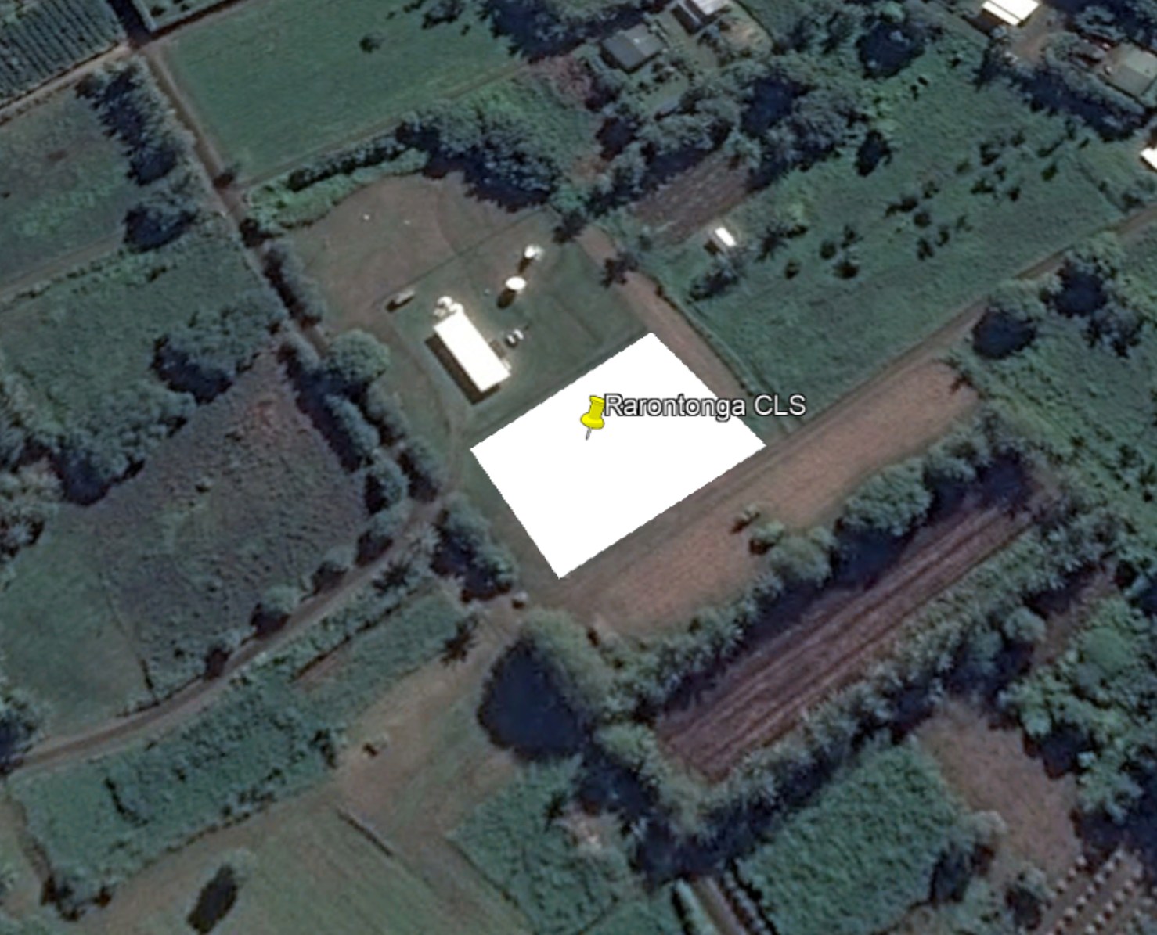

The telecommunication equipment Supplier has provided us with the following floor plan distribution for RAROTONGA CLS:

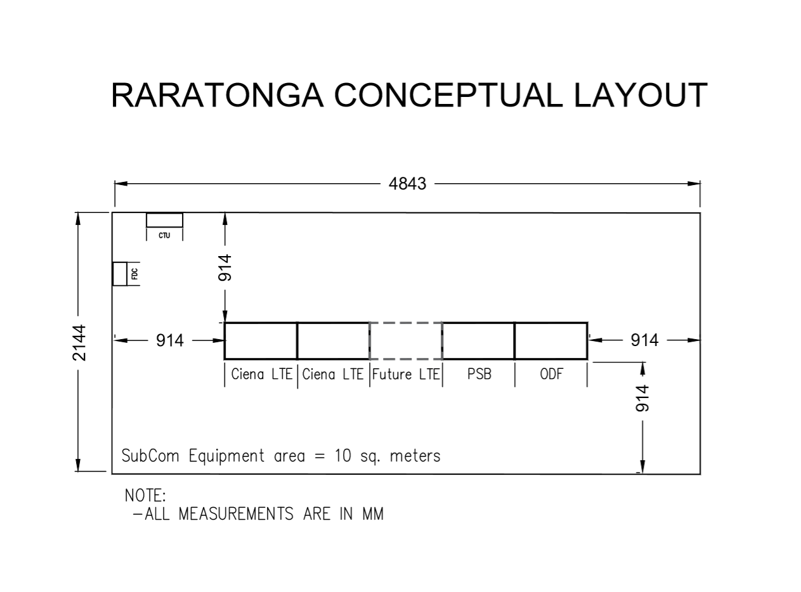
MSB, DC, AC plant, PDP, AirCon, batteries, security system, cabinet, office and chair are not counted in the above area (equipment room) and needs to be taken in account by the Contractor depending on their area requirements. Also the DGS is to be within a room in the CLS.

- Breaker sizes for AC, DC and UPS dedicated to Telecommunication Equipment:

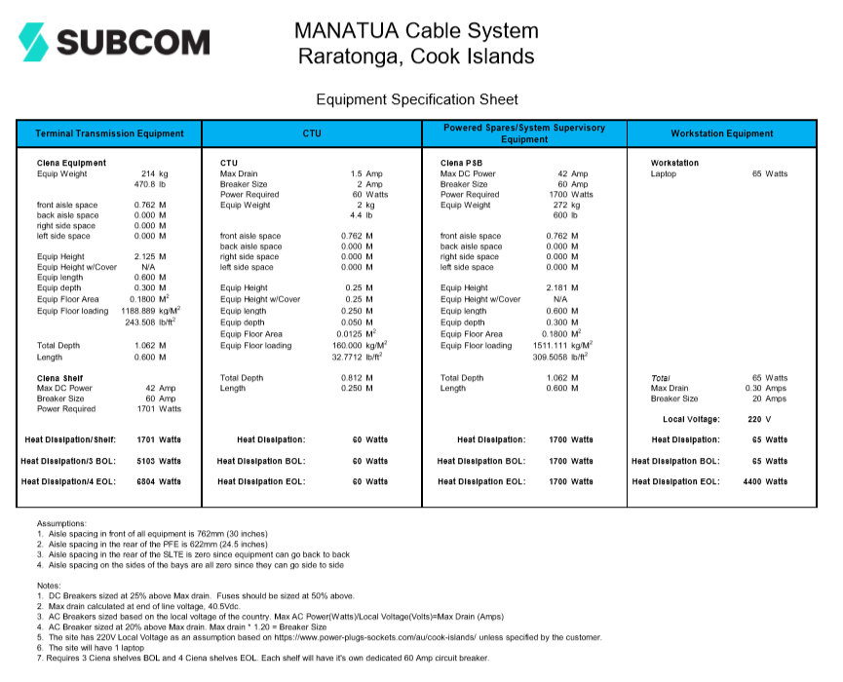

- DC breakers quantity should be provider for the EOL (End Of Life) configuration, while the Rectifiers should be provided for BOL (Begin Of Life) configuration, with the possibility to upgrade to EOL by adding modules (Modules protection still to be considered N:1). Regarding the batteries, 4 hours for BOL to be provided, Contractor to indicated upgradability of batteries to have 4hours for EOL. These DC breakers should be able to accommodate 2AWG cable size. Spare cabled breakers of each type to be provided.
- Additional 1x20A, AC breakers (UPS) required for other wall sockets to accommodate Telecommunication test equipment ( DTA, OSA, OTDR, etc).
- For Air Conditioning, if reaching EOL configuration additional units are required, then BOL configuration is to be provided, with the possibility to upgrade to EOL (space in the room, breakers, ..). If EOL Air Conditioning is to be provided at day 1, Contractor to explain impact on Air Conditioning working behavior (if any). For the Workstation Equipment (Laptop), thanks to consider EOL configuration with 65W (not 4400W).

AITUTAKI:

It is to be noted, that Aitutaki CLS is to be provided without DGS (DGS to be quoted in option 1), indeed, for this site, the Main Energy supplier, is able to provide this DGS service ( as they are already providing such service to the Hospital which is located next door).

The CLS Land is already selected, it is located at the following coordinates 18°52'12.02"S, 159°47'40.49"W.

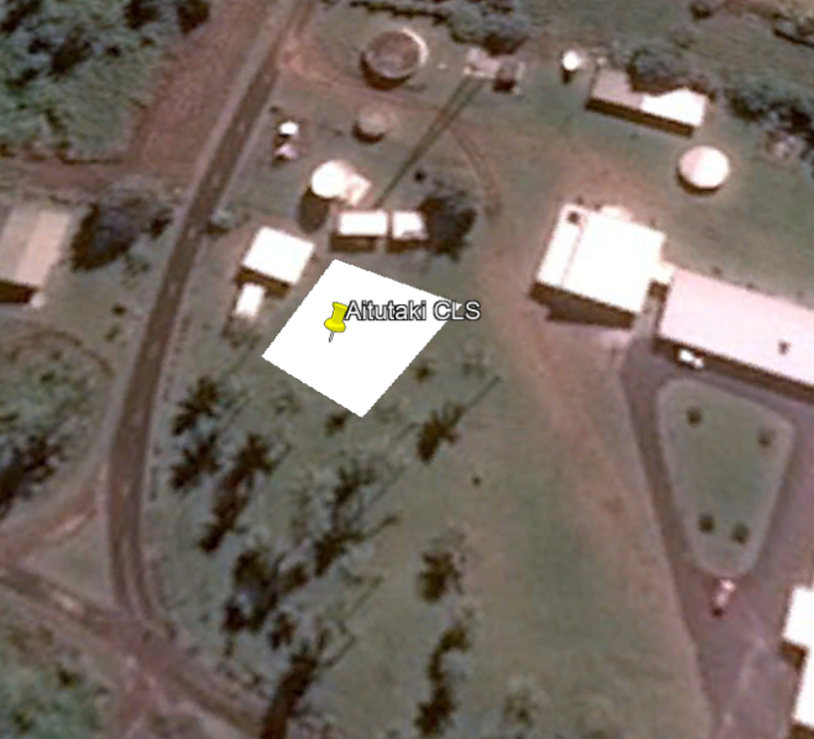

The telecommunication equipment Supplier has provided us with the following floor plan distribution for AITUTAKI CLS:

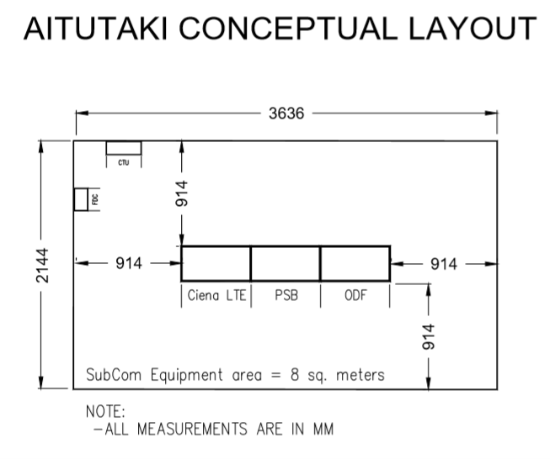

MSB, DC, AC plant, PDP, AirCon, batteries, security system, cabinet, office and chair are not counted in the above area (equipment room) and needs to be taken in account by the Contractor depending on their area requirements. Also the DGS is to be considered a separated room in the CLS (option 1).

- Breaker sizes for AC, DC and UPS dedicated to Telecommunication Equipment:

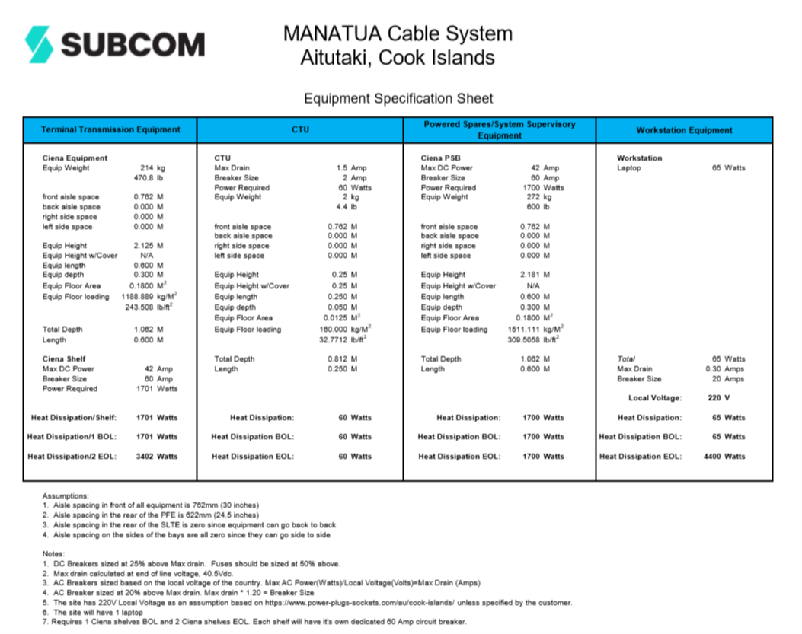

- DC breakers quantity should be provider for the EOL (End Of Life) configuration, while the Rectifiers should be provided for BOL (Begin Of Life) configuration, with the possibility to upgrade to EOL by adding modules (Modules protection still to be considered N:1). Regarding the batteries, 4 hours for BOL to be provided, Contractor to indicated upgradability of batteries to have 4hours for EOL. These DC breakers should be able to accommodate 2AWG cable size. Spare cabled breakers of each type to be provided.
- Additional 1x20A, AC breakers (UPS) required for other wall sockets to accommodate Telecommunication test equipment (DTA, OSA, OTDR, etc).

- For Air Conditioning, if reaching EOL configuration additional units are required, then BOL configuration is to be provided, with the possibility to upgrade to EOL (space in the room, breakers, ...). If EOL Air Conditioning is to be provided at day 1, Contractor to explain impact on Air Conditioning working behavior (if any). For the Workstation Equipment (Laptop), thanks to consider EOL configuration with 65W (not 4400W).

- It is important to note:

  - shipping and transport: https://www.matson.com/matnav/services/south_pacific.html
http://www.pacificfreightmanagement.co.nz/schedule/rarotonga/
http://www.ports.co.ck/services.html
  - Mobile cranage at ports: http://www.ports.co.ck/amenities.html

20' containers are shipped regularly and can be delivered to any location on Aitutaki (with road access).

40' containers with a total weight of LESS than 18,000kg can be landed at the wharf but are difficult to move around the Island as there is no purposed built trailer that can move 40' containers.

It is strongly recommend shipping with 20' containers. It may be possible to move a 40' container if it is needed to, using a low loader trailer that is used for moving the excavators (done so in the past, just requires some organizing).

