Request for Tender

FOR THE SUPPLY AND INSTALLATION OF A
FIRE STATION SECTIONAL GARAGE DOORS

FOR

RAROTONGA INTERNATIONAL AIRPORT, COOK ISLANDS.

Reference No: | CK171814
Date of Release: | (24/11/2017)
- Airport Authority Cook Islands
All queries regarding this Request for Tender should be directed to:
Contact Officer Tony Wearing
twearing@airport.gov.ck
TENDER CLOSING TIME: 4:00p.m. (CI Time) Friday 8th December 2017

Glossary and Definitions
Term | Explanation
BTIB | Business Trade Investment Board
Electronic Tender Account | Asia Pacific Public Electronic Procurement Network e-GP System  https://in-tendhost.co.uk/adbprocurementnetwork/aspx/Home
Policy | The Cook Islands Government Purchase and Sale of Goods and Services Policy
Principal | Airport Authority Cook Islands
RFT | Request for Tender
Tender Team | The group of people responsible for the management of the tender process and includes those people who are specifically responsible to evaluate Tenders.
Manual | The Cook Islands Government Financial Policies and Procedures manual

Table of Contents
Glossary and Definitions 2
Introduction 4
Summary of Requirement 4
CONDITIONS OF TENDERING 4
Contact Officer 4
Tender Registration 5
Tender Closing Time 5
Submission of Tender 6
Conflict of Interest Declaration 7
Further information or clarifications 7
Probity 7
Selection Process 8
Notification of Acceptance 8
Confidentiality 9
Non-Resident Tenderer 9
Mandatory Conditions 9
Attachment 1 – Tender Specification Requirements 10
Tender Specifications 10
Specifications 10
Attachment 2 – Tender Forms To Be Submitted 12
A1 - Form of Tender 13
A2 – Conflict of Interest Declaration 15
A3 - Schedule of Prices 16
A4 – Proposed Subcontractors (if applicable) 17
A5 – Experience and Preliminary Delivery Programme 17
A6 – List of Referees who may be Contacted 18
Mandatory Conditions 19
Evaluation Criteria 19
Risk 20
Draft Contract 21

Introduction

Summary of Requirement
Through this RFT, the Airport Authority Cook Islands wishes to procure the supply and installation of Four (4) Sectional Garage door for the existing Airport Fire Station at Rarotonga International Airport, Cook Islands.
The works of the Contract for the supply and installation, and provide backup parts for maintenance for twelve (12) calendar months of defects liability of parts in accordance with the attached Performance Specification.
It is the tenderer’s responsibility to carry out any site visits necessary.
FIRE STATION DOORS
The Airport Authority Cook Islands wishes to procure the supply and install of Four (4) Sectional Overhead Garage doors with a natural clear anodised aluminium frames; consisting of 4 horizontal sections of powder coated solid aluminium infill panels; plus 3 horizontal section with toughened glass. The height and level of the starting point of the toughen glass starts at the height of a person’s eye level and progress up. This allow for an external/internal view of the other side of the door.
All four (4) Sectional doors are to be opened and closed with a motorised system. They must also have a backup manual operation system, where the strength of one man can open in case of an electricity power failure.
MANUALS AND DOCUMENTATION
All manuals, installation instructions and operating instructions shall be provided in the English language.
EXPERIENCE, PERFORMANCE RECORD, SERVICE CAPABILITIES
The tenderer shall clearly detail their experience, performance record and service capabilities for the equipment. The tenderer shall provide three (3) reference projects similar in size, together with contact information. The tenderer shall clarify the steps that will be taken for a trouble free installation as well as to specify procedures necessary to maintain the equipment.
The tenderer gives the consent to contact the referees provided in the list of referees.
DELIVERY PERIOD
It is a requirement of the Purchaser that the Tenderer clearly states in their Tender the delivery to Rarotonga Airport of its offer to supply the Four (4) Sectional doors from the Date of Award of the Contract. The delivery period of the Doors shall be the earliest possible and not more than 12 working weeks. Delivery is defined as the arrival of equipment to the site.

CONDITIONS OF TENDERING
All tenders should conform to the Conditions of Tendering, but must conform to the Mandatory Conditions as set out in this RFT.

Contact Officer
The Contact Officer for this tender is:
Name of Person: Tony Wearing
Title: Director of Operations
Address: Rarotonga International Airport, Rarotonga, Cook Islands
Phone: +682 25890 or +682 55466
E-mail: twearing@airport.gov.ck

Tender Registration
Prospective tenderers should register their interest to participate in this RFT process by registering on the Cook Islands Government E-Government Procurement portal at:
https://in-tendhost.co.uk/adbprocurementnetwork/aspx/Home

In order to participate in the tender process you will need to register as a supplier on the Portal as a supplier. As part of registration you will need to specify relevant “Business Categories” for your business. This tender will be listed under the following category:
Category | Title
72121402 | Fire station construction service

Prospective tenderers should include this category when registering on the system.
Should there be any issues registering, please advise the Contact Officer as soon as possible and alternative registration processes will be advised. The Contact Officer will acknowledge receipt of the registration. Only registered tenderers will receive notices directly as and when they are issued. It is the responsibility of the tenderer to ensure they are properly registered for this RFT. The Principal reserves the right to extend the list of registered Tenderers beyond those who register interest in this RFT.
Once the Tender is published on the portal any suppliers registered will receive automatic advice of the tender and a link to access tender documentation via the Electronic Tender Account. Submission of tenders will be through the same account.
Suppliers who register after the tender is published will receive notification of the tender upon registration.

Tender Closing Time
Tenders must be received by the Electronic Tender Account or in the tender box specified by the following deadline, or they will not be considered:
Tender Closing Time and Date: 4:00pm (CI Time) Friday 8th December 2017
It is the Tenderer’s responsibility to ensure that their tender reaches the Tender Box located at the Airport Authority Cook Islands Finance Department in the Control Tower Building Level 2 and/or posted to the Electronic Tender Account (https://in-tendhost.co.uk/adbprocurementnetwork/aspx/Home), by the specified closing date and time.
Late tenders will not be accepted.

Submission of Tender
The cost of preparing and submitting the Tender shall be borne by the Tenderer.
The Principal may vary the Tender Specifications described in Attachment 1 at any time, including the closing date, by notice in writing to the Tenderers still involved in the RFT at the time the Tender Specifications are varied.
Tenders shall be submitted in either hard copy or electronic copy, as specified below only.
Telefax tenders will not be accepted.
Hardcopy Submission:
Hardcopy Tenders shall be submitted in three (3) complete copies, packaged and labelled “CONFIDENTIAL” and have the following information clearly exhibited on the outside:
- Airport Authority Cook Islands Tender 11/2017
- ‘Tender for the Supply and Install Four Garage Sectional Doors System for ‘Rarotonga Rescue Fire Station’
- Ref. # 171814
- Tender closes: 4pm, Friday 8th December 2017

Hard copy tenders must be placed in the Tender Box located at the Airport Authority Cook Islands Finance Department in the Control Tower Building Level 2 and submitted in the format contained in Attachment 2 – Forms to be submitted, by the due date.
Failure to do so will result in the tender being disqualified.

Electronic Copy Submission
Electronic copy tenders must be submitted through the Electronic Tender Account in the format contained in Attachment 2 – Forms to be submitted, by the due date. Failure to do so will result in the tender being disqualified.
The default portal is the Asia Pacific Public Electronic Procurement Network e-GP System (refer https://in-tendhost.co.uk/adbprocurementnetwork/aspx/Home). The title and reference number of this document is the tender identifier.
The tender form shall be submitted in Microsoft Word format. Additional documents should be submitted in PDF format. Tenderers should seek approval for any other alternative electronic formats. If offers do not comply with the approved formats they will be deemed non-compliant and may not be accepted.
If the supplier is not able to access or upload tender documents through the default CIG Procurement Portal they should first seek guidance from the user guide using the following link
https://in-tendhost.co.uk/adbprocurementnetwork/aspx/BuyerProfiles
or by clicking the “user guides” tab on the portal. Thereafter further guidance may be available through the Contact Officer.
If still not successful the Contact Officer will arrange a secure email tender account for the upload of documents. The Electronic Tender Account will send a confirmation of receipt email in response to your electronic submission and the time of upload will be used to confirm the date and time of upload. If you do not receive a confirmation of receipt email within five working days please contact the Contact Officer for this tender.
If offers do not comply with the approved formats they will be deemed non-compliant and may not be accepted.

Conflict of Interest Declaration
Tenderers must complete the Conflict of Interest Declaration form in Attachment 2 to disclose any potential or actual conflicts of interest that they may have or may be perceived to have, in respect of their responsibilities to the Principal and other parties should they be selected as the successful Tenderer. Where potential or actual conflicts of interests are identified, the Tenderer must specify how this will be managed in order to provide assurance that it will not adversely impact the performance of any services.

Further information or clarifications
Negotiations will not be permitted between the Tender Team and any prospective tenderers during the tender advertising period.
However, prospective tenderers may seek clarification of the tender documents prior to submitting their tenders.
Tenderers should note that to ensure no disadvantage to any tenderers, responses to ‘Requests for Clarification’ from a Tenderer for any further information for the tenderer or clarifications from the Purchaser will be issued in writing either to all tenderers by way of sequentially numbered Notices to Tenderers or to an individual Tenderer which is deemed commercially sensitive.
‘Request for Clarification’ that are solely a consequence of a Tenderer's proposed methodology or equipment and is deemed to be of a commercially sensitive nature such information will be provided only to the requesting Tenderer and not to other Tenderers.
Any enquiries in relation to this tender should be directed to the Contact Officer at the address given below.
Name of Person: Mr Tony Wearing
Title: Director of Operations
Address: Rarotonga International Airport, Rarotonga, Cook Islands
Phone: +682 25890 or +682 55466
E-mail: twearing@airport.gov.ck

Probity
No gifts or entertainment of any nature will be permitted between any parties involved throughout the tender process, including: tenderers or potential tenderers, tender team members, evaluation team members, the Head of Ministry, or any other member or organisation that may have an involvement with any aspect of the tender process.

Selection Process
All tenders received in the Tender Box and/or Electronic Tender Account by the closing date and time will be assessed on whether they have conformed to the Mandatory Conditions. Failure to comply with these conditions will result in immediate exclusion from the Evaluation process. All Tenders deemed compliant will then proceed to the evaluation stage.
Evaluation of the responses to this RFT will be in accordance with the Evaluation Criteria described in Attachment 3.

Notification of Acceptance
Tenders shall remain valid for acceptance and shall not be withdrawn for a period of sixty (60) working days from the Closing Date of the tender.
Unsuccessful tenderers shall be notified in writing by the Principal or their representative within ten (10) working days of acceptance of the successful tender.
If no tender is accepted by the Principal within twenty (20) working days after the Closing Date, each tenderer will be notified in writing by the Principal or their representative whether their tender is still under consideration or is no longer being considered.
When the preferred Tenderer has been identified, the Principal will invite the Tenderer to enter into negotiations based on the draft contract in Attachment 4 to this RFT. Only when both parties have agreed to the terms of the contract and executed the contract, will the Principal formally issue a Letter of Acceptance to the successful Tenderer
The successful tenderer will be notified by the Principal. For their representative in writing on a date yet to be confirmed, but within sixty (60) working days from the Closing Date of the tender.
The Tender Team reserves the right to contact referees and/or customers regarding the performance of the tenderer as it may pertain to this RFT.
The Principal shall not be bound to accept the lowest priced tender or the highest scored tender or any tender.
Tenderers are entitled to the release of their evaluation report on request. Any requests for evaluation reports of other tenders must be processed under the Official Information Act 2009.
Tenderers have the right to make a complaint and may do so under the complaints process of the Cook Islands Government Purchase and Sale of Goods and Services Policy.
If no tender has been accepted within the period stated, the Principal will notify all Tenderers that no tender was accepted and may:
- Invite all Tenderers to provide additional information; and/or
- Re-advertise the RFT and extend the closing date of the Tender. Tenderers may either resubmit their tender or provide additional information to support their existing Tender already received by the Principal
The tenderer must confirm their acceptance of the terms of the contract for services attached at Appendix D. If the tenderer is unable to agree to any clause, it must set out in a table form the clause reference, reason why the tenderer cannot accept it and proposed alternative wording.
At the conclusion of the tender process the outcome will be published on the procurement website showing the names of the successful Tenderer.

Confidentiality
Drawings, Specifications, Schedules and written technical information supplied to Tenderers shall not be used for purposes other than the preparation of a Tender without the approval of the Principal. Information submitted by a Tenderer shall be regarded as confidential and shall not be disclosed to a third party except with the prior written agreement of the Tenderer.

Non-Resident Tenderer
In order for foreign companies to carry out business in the Cook Islands, an application for, and approval, must be sought from the Business Trade Investment Board (BTIB). Any fees associated with the registration are to be covered by the Tenderer. Tenderers should inform themselves of the registration process and confirm in their Tender that they are willing to register once a Letter of Acceptance is issued. Information can be found at www.btib.gov.ck.

Mandatory Conditions
All tenders must conform to the Mandatory Conditions below. Any tender that fails to comply with one or more of the mandatory requirements will be deemed non-compliant and will be excluded from the evaluation process. Mandatory Conditions below are also reflected in Attachment 3 – Evaluation Criteria.
- Tenders must be completed in the format contained in Attachment 2 of this RFT. If offers do not comply with this format contained in Attachment 2, they will be deemed non-compliant and may not be accepted.
- Tenders must be deposited in the required form in the Tender Box or the Electronic Tender Account by the closing time as specified in this RFT.
- All tenders and related documentation in respect of this RFT may be presented in the English or Maori language. Tenders presented in Maori or any other language must be provided with an English translation.
- Tenderers must tender to provide services or supply materials for the whole of the contract works as specified in the Tender Specifications.
- Tenders must be presented in hard copy format and/or electronic copy format as specified in this RFT.
- All prices quoted must be inclusive of freight, Levies landed and relevant charges to the final point of delivery to Rarotonga Airport.
- All prices must be in New Zealand dollars.

Attachment 1 – Tender Specification Requirements
  - Tender Specifications

Specifications

DOOR 1, Current door opening width 4600mm height 3950mm.
DOOR 2, DOOR 3, and DOOR 4 Current door opening width 4260mm height 3950mm
- The doors are to be operated with a motorised opening and closing system.
- The doors are to have a manual back up for manual operation in case of a power failure. And to be open by the strength of one person.
- The opening switch to be mounted on the inside wall right hand side by the door when facing outwards.
- The doors are to be of a natural clear anodised aluminium frames; consisting of 4 horizontal sections of powder coated solid aluminium infill panels; plus 3 horizontal section with toughened glass. The starting point of the toughen glass starts at the third horizontal section from the ground and progress up. This allow for an external/internal view of the other side of the door and allows natural light into the building.
- All doors must open fully to exposed the fully opening of each door height of 3950mm

ADDITIONAL
- An alternative door open only switch for all doors to be fitted in the Control Room.
- Door 4 will have an additional switch mounted on the external wall for open only for that door.
- All equipment’s supplied must meet New Zealand approval standards.
- All electrical components mounted outdoors will be subject to all weather conditions and should be suitable for use in a coastal and humid tropical environment.
- All window panes shall be manufactured with toughened safety glass or material of similar properties.
- The equipment shall operate from an individual 240 Volt, 50 Hz, single phase power supply. A wiring diagram of electrical equipment will be required from the successful bidder.

DEFECT LIABILITY PERIOD AND REVIEW
The Supplier shall grantee materials will be available for the works of this contract for a period of twelve (12) calendar months from practical completion. Suppliers warranties and guarantees shall be extended and paid for by the Supplier (where they may have otherwise expired) to fulfil this obligation.
The Defects Liability Works shall include “Repair” or “Replacement” of faulty components;

PHOTOS OF CURRENT SETUP
Current Door down.
- 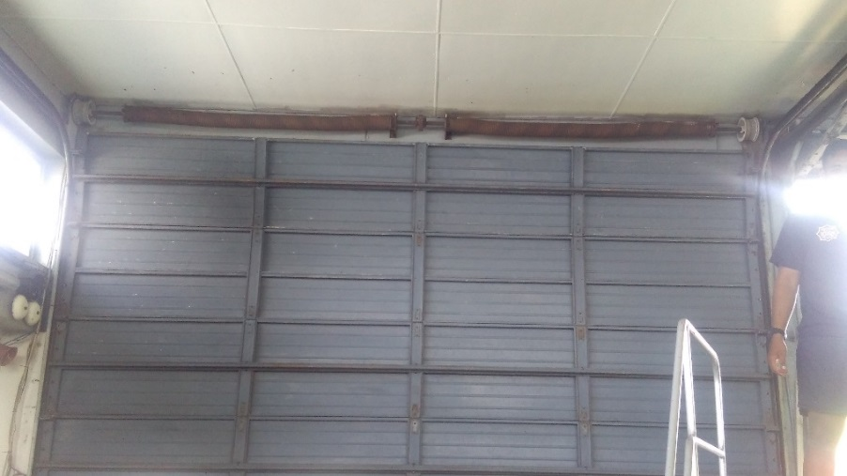
Note available space from track to ceiling.
- 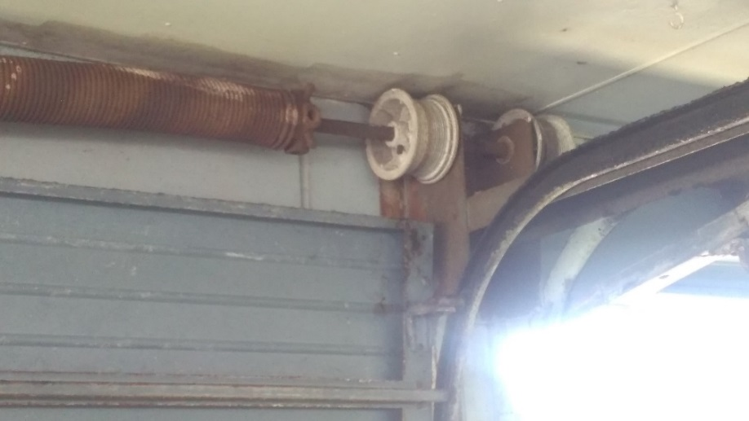
Note space between end and centre columns.
- 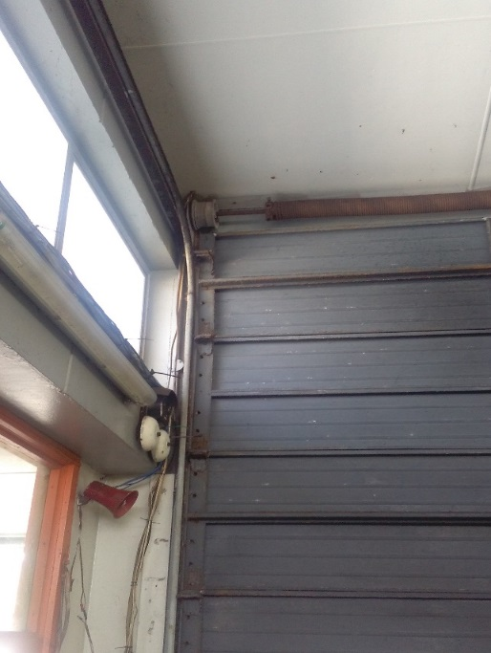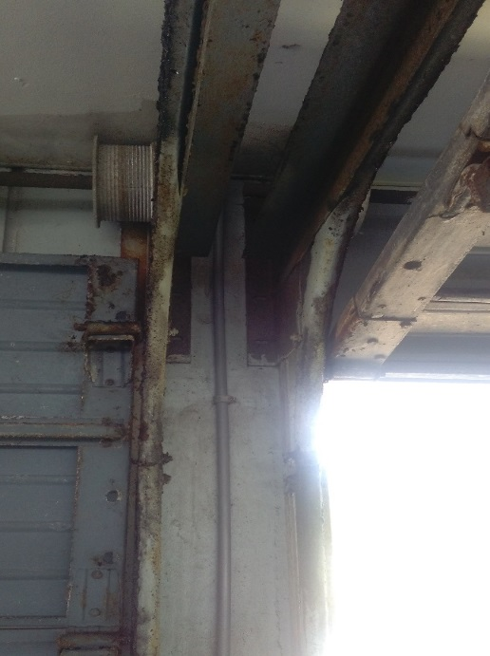

Attachment 2 – Tender Forms To Be Submitted

Instructions
1. Tenderers must complete and submit all of the following forms, in the formats provided in this Attachment:
- A1 – Tender Form
- A2 – Conflict of Interest Declaration
- A3 – Completed Schedule of Prices
- A4 – Proposed Subcontractors (if applicable)
- A5 – Experience and Preliminary Delivery Programme
- A6 – List of Referees you may contact in relation to this offer.
2. Tenderers who fail to supply all of the items listed in above, will be deemed non-compliant and will be excluded from the tender evaluation process.

  - A1 - Form of Tender

Mr Tony Wearing
Airport Authority Cook Islands,
Control Tower Building Level 2,
Rarotonga, Cook Islands

Tender For: | Supply and Installation of a Fire Station Sectional Garage Doors for Rarotonga International Airport, Cook Islands
Supplier: | [Name of supplier]

Having examined the Tender Documents in relation to Tender Reference No. 171814 and dated 24th November 2017, released by Airport Authority Cook Islands, we submit the following offer.
We offer to supply and install Four (4) Sectional Overhead Garage doors as per the Tender Specifications and conformity with these Tender Documents for the sum of [insert the price offered in text with the value in numbers thus (NZD$__________.__)] stated exclusive of Value Added Tax, together with such other sums as may be ascertained in accordance with the Contract.
We acknowledge receipt of Notices __________ to __________.
We agree/disagree to the Terms and Conditions of the Purchase Agreement in Attachment 4 of the said tender and do not propose any amendments.
We undertake to complete whole/part of the Contract works and handover within the period stated in the Tender conditions.
We agree to abide by this Tender for a period of sixty (60) working days from the date fixed for receiving the same and it shall remain binding upon us and may be accepted by you at any time before the expiry of that period.
Unless and until a Contract Agreement is prepared and executed, this Tender together with your written acceptance thereof, shall constitute a binding contract between us.
We understand that you are not bound to accept the lowest or any Tender you may receive.
We understand that no contract shall come into existence, and no legal or other obligations shall arise between us and you (or between us and any other agent of the Principal) in relation to the conduct, outcome or otherwise of the Tender process, prior to and apart from your acceptance of our Tender.
We understand that you may contact the referees nominated by us in this offer and make whatever enquiries you deem necessary regarding our financial health and ability to deliver the Contract Works/Goods/Services. Further, during the assessment stage we understand and agree that you may request specific information from all tenderers in order to assist your assessment. We acknowledge that a failure to provide such information may result in disqualification from the process.
We provide the following information required to be submitted with this Tender:
- A2 – Conflict of Interest Declaration
- A3 - Completed Schedule of Prices
- A4 - Proposed Subcontractors (if relevant)
- A5 - Preliminary Delivery Programme
- A6 - List of Referees you may contact in relation to this offer.

If the tenderer is unable to agree to any clauses included in the Conditions to the Contract, it must set out in a table form the clause reference, reason why the tenderer cannot accept it and proposed alternative wording.
Tenderers details:
Tenderers full name:
Tenderers trading name (if Company):
Contact person (if Company):
Postal address:
Physical address:
Phone number:
Mobile:
Email address:
Signature |  |  | Date
Full Name |  |  | Position (if Company)

  - A2 – Conflict of Interest Declaration
A conflict of interest arises if you or a close family member has an interest e.g. is a board or committee member or is employed in a senior position in the Government agency that wants to purchase the goods or services relating to this tender process.

In submitting this tender bid I declare:
- I understand that an actual, potential or perceived conflict of interest may arise in participating in this tender process and that I am obliged to declare any such conflict of interest.
- I confirm that in submitting this information that I have either declared any potential conflicts of interest or that I am not aware of any situation or issue that would conflict with the interest of the Principal.
- If a conflict of interest arises at any time before the selected supplier has been awarded, I will advise the Contact Officer or the Principal immediately.
- I have personally completed this declaration on behalf of the Supplier(s) and declare that the submitted tender bid provided are true and correct.

I declare that I have a potential conflict of interest as follows:
I will manage this conflict of interest by:
Declared by:
Signature |  | Date
Full Name |  | Position (if Company)

  - A3 - Schedule of Prices
Unit Description | NZD$ Cost (Excl VAT) | VAT Cost | NZD$ Cost (incl VAT)
Door 1
Door 2
Door 3;
Door 4;
Electrical motor per door
Manual operation system to open door in case of electrical failure
Open and close switch unit per door
One external mounted switch unit to open only, door 4
One open switch for all doors to be fitted in the control room
Electrical cable for wiring each unit switch
Shipping and associated costs to onsite Rarotonga Airport
Other - please specify if applicable
TOTALS

  - A4 – Proposed Subcontractors (if applicable)
Subcontractor details:
Subcontractors full name:
Subcontractor s trading name (if Company):
Contact person (if Company):
Postal address:
Physical address:
Phone number:
Mobile:
Email address:
Works/Skills to be performed:

Educational/Technical Qualifications:

Work Experience:

Potential or Actual Conflicts of Interest:

  - A5 – Experience and Preliminary Delivery Programme
Tenderer to provide details on experience, performance record and service capabilities for the equipment and similar. Tenderer to also provide a delivery schedule.
Tenderer must include the following:
- Three (3) reference projects similar in size, together with contact information (may be similar or separate to referees provided in A6),
- Preliminary delivery schedule to Rarotonga Airport,
- Clarify the steps that will be taken for a trouble free installation, and
- Specify procedures necessary to maintain the equipment.
The Tenderer may provide the above information in their own template format.
The above will be taken into consideration during the Evaluation Process.

  - A6 – List of Referees who may be Contacted

Name: | ________________________________________________________________
Company: | ________________________________________________________________
Address: | ________________________________________________________________
 | ________________________________________________________________
 | ________________________________________________________________
E-mail Address: | ________________________________________________________________
Phone No.: | ________________________________________________________________
Facsimile No.: | ________________________________________________________________
Nature of Relationship with Tenderer:

Name: | ________________________________________________________________
Company: | ________________________________________________________________
Address: | ________________________________________________________________
 | ________________________________________________________________
 | ________________________________________________________________
E-mail Address: | ________________________________________________________________
Phone No.: | ________________________________________________________________
Facsimile No.: | ________________________________________________________________
Nature of Relationship with Tenderer:

Attachment 3 – Evaluation Criteria
The Mandatory Conditions have been drawn from the Conditions of Tendering in this RFT. Tenders that do not meet the Mandatory Conditions are deemed non-compliant, and will not proceed into Evaluation.

Mandatory Conditions
Tenders must pass all of the following requirements. Tenders that do not meet one or more of these conditions are deemed non-compliant and will not be considered.
Criterion | Complies Yes or No
- Tender is completed in the format contained in Attachment 2 of the RFT.
- Tenders must be deposited in the required form in the Tender Box and/or the Electronic Tender Account by the closing time specified in the RFT.
- Proposal and related documentation must be in the English language or translated into English.
- Tenderers must tender to provide the whole of the works/goods/services specified in the RFT.
- Tenders must be presented in electronic copy and/or hard copy format (three (3) complete copies) as specified in this RTF only.
- All prices must be in NZ dollars and inclusive of freight landed and relevant charges to Rarotonga Airport.

Evaluation Criteria
Criteria | Weight %
Non-Price Criteria
- Locally established company or resources (labour and/or materials) | 5
- Acceptance of the contract terms | 5
- Relevant Experience | 10
- Past Performance | 5
- Compliance with specifications | 10
- Time Required from Award to Commissioning | 5
Total Non-Price Elements | 40
7. Price | 60
TOTAL WEIGHTING | 100
A Weighted Criteria methodology will apply to the evaluation of this RFT as follows:

Risk
The Evaluation Committee will conduct a Risk Assessment for each Tender submitted. This will identify the most significant risks presented by the Tender and consider the Likelihood of the risk occurring; the consequence of that risk; and a risk mitigation strategy. In conclusion, the mitigated risk will be determined to form an overall measure of the risk represented by each Tender.
The Risk Mitigation Strategy may include the inclusion of specific clauses in the executed contract. Therefore, a Tender considered to be High Risk might still be selected subject to the Tenderer’s willingness to accept the proposed contract amendments.
Attachment 4 – Contract Conditions
  - Draft Contract

PURCHASE ORDER
Government: Her Majesty the Queen acting by and through The Airport Authority Cook Islands
Signed:_____________________________
Name:
Position:
Date:
Supplier: [Insert Supplier details]
Signed:_____________________________
Name:
Position:
Date:
_____________________________________________________________________________________
Product and Services: To supply and install Four (4) Sectional Overhead doors as per specifications in the Tender document.
Delivery: Product and Service to be delivered and installed on site at the Rescue Fire Station, Rarotonga Airport not more than 12 working weeks from acceptance of Tender.
Price: 10% on award of tender, 60% on shipment, 20% on delivery to Airport and 10% after acceptance of Tender.
Insurance: Insurance prior to acceptance will be the responsibility of the supplier.
Contact Person:
Government Contact: Tony Wearing, Director of Operations, Airport Authority Cook Islands.
Supplier Contact: [insert details]
Additional Terms: Nil.
TERMS AND CONDITIONS FOR SUPPLY OF PRODUCT AND SERVICES

The Supplier agrees to supply the Product and Services categorised above and more specifically described and detailed in the Purchase Order issued by the Government of the Cook Islands (the “Government”) on the following terms and conditions:
- APPLICATION
These terms and conditions apply to all purchases of Product and Services except where the Government agrees in writing that they be varied or do not apply. These terms and conditions supersede any contrary provisions in the Supplier’s terms and conditions of supply including those terms that the Supplier normally uses. No right under these terms and conditions shall be deemed to be waived except by notice in writing by each party. In the event that any one or more of the provisions contained in these terms and conditions are declared invalid by an order, decree or judgment of any Court of competent jurisdiction, these terms and conditions will be read as if such provision had not been inserted.
- PRICES
  - The prices stated on the Government’s Purchase Order are fixed, unless there is a written agreement stipulating the price may be varied, when it may be varied and how the price is to be determined.
  - The price includes the Services, freight, insurance, packaging, crating, local cartage, customs duty and/or any other services in the delivery of the Product.
  - The price is exclusive of VAT.
  - The Supplier is not entitled to claim expenses, surcharges or margins or disbursements except if otherwise agreed in advance and in writing by the Government.
- DELIVERY
  - The time of delivery and performance of the Product and Services is a fundamental element of these terms and conditions.
  - The Product and Services shall be delivered and rendered in a prompt and timely manner on or within the delivery dates specified in the Purchase Order. All Product and Services must be delivered and performed within the Government business hours (normal business hours are 8:00 am to 4:00 pm, Monday to Friday), unless otherwise specified in the Purchase Order.
  - The Supplier shall notify the Government in writing immediately when the Supplier becomes aware there may be a delay in the delivery of Product or rending of Services to the Government.
  - The Government is entitled to cancel the Purchase Order or change its specification (without incurring additional charges) if the Product and/or Services are not supplied on the supply dates or times specified in the Purchase Order.
  - All Product and Services must be supplied to the address specified in the Purchase Order. The Supplier shall make itself aware of any special requirements when supplying the Product and Services to Government property.
  - When Product is delivered to the Government it shall be accompanied by a delivery docket that records the Purchase Order number, the description, quantity with the applicable units of measure, unit rates and dollar values of the Product and Services delivered. The delivery docket must be signed for and retained by a Government officer.
  - All Product shall be packaged in a manner to prevent damage or deterioration when being delivered to the Government.
  - The Government may use other suppliers for the supply of Product and Services, or product and services of the same nature as the Product and Services, at any time.
- IDENTIFICATION
  - The Purchase Order number must be shown on all packages, invoices and correspondence relating to the Product and Services. Product supplied against an invalid Purchase Order or without a Purchase Order, will be returned to the Supplier at the Supplier's expense including the cost of packaging, transportation, insurance and handling of the Product and Services.
  - Where applicable, the Supplier grants the Government access to the Supplier’s premises, facilities and staff concerning the delivery and identification of the Product. The Government shall have the right to audit and inspect the Supplier’s records concerning delivery of the Product and rendering of the Services. These rights are for both the Government and any other party that has the use or benefit of the Product and Services.
- QUALITY, INSPECTION AND ACCEPTANCE
It is a condition of these terms and conditions and the Supplier warrants that:
  - All Product and Services shall be in accordance with any requirements set out in these terms and conditions and/or in the Purchase Order and shall be free from defects in workmanship, materials and design. These obligations survive acceptance of the Product and Services and payment.
  - The Supplier shall use the highest reasonable standard of skill, care and quality and employ techniques, methods, procedures and materials of a high quality and standard in accordance with best professional practice in providing the Product and rendering the Services.
  - The Supplier will comply with all relevant (a) Cook Island standards and international standards (if not in conflict) (both general and industry-specific); (b) statutes; (c) regulations; (d) by-laws; (e) ordinances; and (f) Government policies, applicable in respect of the supply of the Product and rendering the Services.
  - Where the Supplier has the benefit of any warranties or covenants from a third party in respect of the Product and Services, the Supplier shall disclose and assign the benefit of the warranties and/or covenants to the Government.
  - The Product and any result or product of the rendering of the Services, its material and workmanship, shall be subject to inspection and testing at all reasonable times and places by the Government (or those parties to whom the Government supplies the Product) before, during or after delivery.
  - If inspection and testing is to be conducted on the premises of the Supplier or the Supplier’s sub-contractors, the Supplier shall provide (without additional charge) all reasonable facilities and assistance for the safe and convenient inspection and testing required by the Government's inspectors in the performance of their duty.
  - The Supplier acknowledges that the signing of a delivery note or similar on behalf of the Government does not constitute acceptance of any Product and Services. The Government may reject any Product and Services (as applicable), even after they have been accepted, that: (a) are not of merchantable quality; (b) are not fit for purpose as stipulated in the Purchase Order; (c) are in an unsatisfactory condition or not functioning in the way they are designed to function; or (d) do not otherwise meet the requirements (including requirements relating to delivery) of these terms and conditions, or in circumstances where the Services do not meet the requirements of clause 5.1("Rejected Product"/"Rejected Services").
  - For any Rejected Product or Rejected Services the Supplier will, within ten (10) business days of receiving notice of Government's rejection of the Rejected Product or Rejected Services, at the Government's sole and absolute discretion and at the Supplier's sole risk and expense: (a) repair the Rejected Product; (b) replace the Rejected Product; (c) request the re-performance of the Services (d) remove the Rejected Product for full credit or reimbursement; or (e) suspend or cancel the Services, and in the case of clause 5.8(c), reimburse/credit the Government in full for any amounts paid by the Government in respect of the Rejected Product or Rejected Services, as the case may be.
  - Title to the Rejected Product will pass back to the Supplier on the earlier of the replacement of the Rejected Product, repair of the Rejected Product or, refund or credit of any amounts paid by the Government as specified in clause 5.8(c).
  - Clauses 5.7 and 5.8 do not limit or negate any other rights or remedies that the Government may have under these terms and conditions or at law.
  - A lack of Government inspection does not relieve the Supplier of any responsibility to perform its obligations according to these terms and conditions.
- OWNERSHIP AND RISK
  - Subject to clauses 5.7 and 5.8:
    - title in the Product passes to the Government when the Product is delivered to the Government or when the Government completes payment for the Product, whichever is the earlier date;
    - the Product remains at the Supplier’s risk until the Product is delivered to the Government and is declared by the Government as not being Rejected Product or Rejected Services.
  - Where the Product is delivered to the Government subject to the Services, the Product remains at the Supplier’s risk until the Government is satisfied with the complete rendering of the Services.
- PAYMENT
  - The Supplier shall provide to the Government’s Contact Person, within five (5) business days of the end of the month following delivery of the Product or rendering of the Services, a VAT tax invoice for each delivery of the Product and rendering of the Services, stating Purchase Order number, date of delivery and full description of the Product and Services and quantity delivered. Invoices received without all of these details will be returned to the Supplier, unpaid.
  - If monthly charges are applicable, the Supplier shall supply to the Contact Person specified in the Purchase Order a monthly statement of that month’s deliveries not later than the tenth business day of the month following delivery.
  - Invoices and statements are to be addressed to the address specified in the Purchase Order.
  - Subject to clause 5, payment for Product delivered, once approved, will be effected on the first Wednesday on or after the 20th of the month following the date of the Supplier’s VAT tax invoice or receipt of the delivery of the Product, whichever is the later.
  - Any invoices provided by the Supplier which have not met the requirements of this Payment clause will not be affected.
  - Payment will be effected by Electronic Funds Transfer (EFT) (direct credit).
- CONFLICT
  - The Supplier confirms it has no knowledge of any conflict of interest in providing the Product and rendering the Services.
  - If any conflict arises or has the potential to arise during the supply of the Product and Services, the Supplier shall immediately inform the Government in writing and the Government will decide on the appropriate steps to be followed in such event, which may include the right of the Government to terminate the Purchase Order with immediate effect.
- INTELLECTUAL PROPERTY
  - “Intellectual Property” includes copyright, designs, drawings, specifications, reports, data and documentation. All Intellectual Property arising from the provision of the Services (“New IP”) is owned by the Government and the Supplier shall co-operate with the Government (including by signing documents) to help the Government protect its rights in the New IP.
  - To the extent that New IP incorporates or requires Intellectual Property arising outside of the provision of the Services (Pre-existing IP), the Supplier licences, or shall procure the licence to the Pre-existing IP for the Government on a perpetual, royalty-free basis.
  - The Supplier warrants and represents to the Government that the New IP and the Pre-existing IP will not infringe the Intellectual Property rights of any third party.
- ASSIGNMENT
The Supplier shall not assign or sub-contract any rights or obligations applicable under these terms and conditions without the prior written consent of the Government given at its discretion.
- NOTICES
  - All correspondence shall include the Purchase Order number and addressed to the Government’s Contact Person named on the Purchase Order form.
  - All correspondence shall be in writing sent by email, mail with postage prepaid or by hand delivery to the address for notices as set out above or such other address as a party has notified in writing.
  - Subject to clause 11.4, notice given in person is deemed to be served upon delivery or by post three (3) business days after the date of posting. Any notice served on a non-business day is deemed to have been served on the first business day after that day. Any notice by email shall be deemed to be received on the first business day after such email has reached the receiver’s designated information system for receiving emails or, in all other situations, when the email comes to the receiver’s attention.
  - The Government shall only be deemed to have received delivery of a notice upon the Government acknowledging in writing receipt of the notice.
- INDEMNITY
The Supplier indemnifies the Government in respect of all costs (including legal costs), claims, liabilities, losses, damage and expenses suffered or incurred by the Government and any other person claiming through the Government as a direct or indirect consequence of any unlawful, negligent, tortious, criminal, reckless or dishonest errors, acts or omission of the Supplier in the performance of its obligations under these terms and conditions. This indemnity survives the termination of these terms and conditions.
- REMEDIES
The Supplier shall not be entitled to anticipatory profits or to special (including multiple or punitive), incidental or consequential damages or losses.
- INSURANCES
  - The Supplier shall take out and maintain at its own cost, at all times during the continuance of these terms and conditions, such insurances as specified in the Purchase Order. All such insurance shall be on such terms and with such insurers as the Government may reasonably require.
  - The Supplier shall, if requested by the Government, provide the Government with written evidence that all insurances are in force and shall produce, whenever reasonably required by the Government, the relevant policies and evidence of payment of the current premiums. If the Supplier fails to provide such evidence the Government may, after notifying the Supplier in writing, arrange or keep in force that insurance and may, for the purpose of doing so, pay the relevant premiums and deduct a corresponding amount from any moneys payable by Government to the Supplier under these terms and conditions.
- LAW
These terms and conditions are governed by the laws of the Cook Islands. The parties agree to submit to the non-exclusive jurisdiction of the High Court of the Cook Islands.
- TERMINATION FOR CONVENIENCE
Notwithstanding anything to the contrary contained in these terms and conditions, the Government shall be entitled to cancel any applicable Purchase Order, at its convenience, on 10 business days' written notice to the Supplier; provided the Government will pay for all Product and Services rendered delivered to the satisfaction of the Government in respect of any Purchase Order, prior to the date of notice of cancellation.
- GENERAL WARRANTIES
The Supplier represents, warrants and undertakes that:
  - it has full power, capacity and authority to execute, deliver and perform its obligations under these terms and conditions or any Purchase Order;
  - it has and will continue to have, all necessary consents, permissions, licences and rights to enter into and perform its obligations under these terms and conditions or any Purchase Order;
  - there are no existing agreements, undertakings or arrangements which prevent it from entering into these terms and conditions or which would impede the performance of its obligations under these terms and conditions or any Purchase Order;
  - it has not offered any inducement in connection with the entering into or negotiation of these terms and conditions or any Purchase Order and;
  - it has not (nor is any of its representative directors or employees) a party to any litigation, proceedings or disputes which could adversely affect its ability to perform its obligations under these terms and conditions or any Purchase Order.

- DISPUTE RESOLUTION
In the event of a dispute arising between the parties in respect of any matter in relation to this Agreement, the authorised representatives of each party will negotiate a resolution. If the dispute cannot be resolved by negotiation within five days of service by one party to the other of the written notice of a dispute arising, the dispute will be referred to arbitration under the Arbitration Act 2014.

