Request for Tender

Mauke Fishing Boats Project: Supply and Delivery of Boats Trailers and Accessories

Reference No: | 161730
Date of Release: | 06 April 2017

Office of the Prime Minister
All queries regarding this Request for Tender should be directed to:
Contact Officer Boyd Ellison
boyd@akairoconsulting.com
TENDER CLOSING TIME: 2pm (CI Time) Monday 1 May 2017

[This page is intentionally left blank]

Table of Contents
Glossary and Definitions 4
Introduction 5
Summary of Requirements 5
CONDITIONS OF TENDERING 5
Contact Officer 5
Tender Registration 5
Tender Closing Time 6
Submission of Tender 6
Conflict of Interest Declaration 7
Further information or clarifications 7
Probity 7
Selection Process 7
Notification of Acceptance 8
Confidentiality 8
Non-Resident Tenderer 9
Mandatory Conditions 10
Special Conditions 10
Attachment 1 – Tender Specification Requirements 12
Tender Specifications 12
Attachment 2 – Tender Forms To Be Submitted 18
A1 – Form of Tender 19
A2 – Conflict of Interest Declaration 21
A3 – Completed Schedule of Prices 22
A4 – Proposed Subcontractors (if applicable) 23
A5 – Preliminary Delivery Programme 24
A6 – List of Referees who may be Contacted 25
Attachment 3 – Evaluation Criteria 26
Mandatory Conditions 26
Evaluation Criteria 27
Risk 28
Attachment 4 – Contract Conditions 29

Glossary and Definitions

TERM | EXPLANATION
BTIB | Business Trade Investment Board
Manual | The Cook Islands Government Financial Policies and Procedures manual
Policy | The Cook Islands Government Purchase and Sale of Goods and Services Policy
Principal | Office of the Prime Minister
RFT | Request for Tender
Tender Team | The group of people responsible for the management of the tender process and includes those people who are specifically responsible to evaluate Tenders.
CIF | Cost Insurance Freight
NTT | Notice to Tenderers
OPM | Office of the Prime Minister

Introduction

Summary of Requirements
Through this Request for Tender (RFT), the Office of the Prime Minister (OPM) wishes to tender for the supply and delivery of 3 aluminium fishing boats, trailers, trollies, aluminium ladder and all required accessories. The Consignment is to be delivered to the island of Mauke. The boats and accessories can be supplied complete to the island of Mauke or constructed on site. Your tender submission shall clearly state how you will intend to deliver the requirements of the tender.
The scope of the tender includes supply and delivery of the materials to Taunganui Harbour Mauke and onto the local government storage yard.
Tenderers must tender to provide services or supply materials for the whole of the works/good/services as specified in the Tender Specifications.
It is the tenderer’s responsibility to carry out any site visits in order to assess the true costs to complete the project where necessary.

Tenderers can register with the Contact Officer Boyd Ellison by email to the following address: boyd@akairoconsulting.com in order to receive an electronic copy of this RFT. Notice to Tenderers (NTT) will only be sent to those potential Tenderers who have registered their interests with the Contact Officer or who register at the Climate Change Office of the OPM.

Tenderers can also uplift hard copies from the Climate Change Office of OPM, Avarua, Rarotonga and must register their receipt of the tender documents on the tender log form.

CONDITIONS OF TENDERING
All tenders should conform to the Conditions of Tendering, but must conform to the Mandatory Conditions as set out in this RFT.

Contact Officer
The Contact Officer for this tender is:
Name of Person: Boyd Ellison
Title: Contact Officer
Address: Po Box 3205
Phone: + 682 54461 or +682 54221
E-mail: boyd@akairoconsulting.com

Tender Registration
Prospective tenderers should register their interest to participate in this RFT process by emailing the Contact Officer who will acknowledge receipt of the registration. Only registered tenderers will receive notices directly as and when they are issued. It is the responsibility of the tenderer to ensure they are properly registered for this RFT. The Principal reserves the right to extend the list of registered Tenderers beyond those who register interest in this RFT.

Tender Closing Time
Tenders must be received by the Electronic Tender Account or in the tender box specified by the following deadline, or they will not be considered:
Tender Closing Time and Date: 2.00pm (CI Time) Monday 1 May 2017
It is the tenderer’s responsibility to ensure that an original copy of the tender reaches the Climate Change Office, Office of the Prime Minister, Avarua, Rarotonga, Cook Islands or to the Electronic Tender Account, Mauke Fishing Boats by the specified closing date and time.
Late tenders will not be accepted.

Submission of Tender
The cost of preparing and submitting the Tender shall be borne by the Tenderer.
The Principal may vary the Tender Specifications described in Attachment 1 at any time, including the closing date, by notice in writing to the Tenderers still involved in the RFT at the time the Tender Specifications are varied.
Tenders shall be submitted in either hard copy or electronic copy, as specified below only.
Telefax tenders will not be accepted.

Hard Copy Submission:
Original hard copy tenders shall be packaged and labelled “CONFIDENTIAL” and have the following information clearly exhibited on the outside:
Chief of Staff
Office of the Prime Minister
Avarua
Rarotonga
COOK ISLANDS

- Tender for: Mauke Fishing Boats Reference No.161730
- Tender Closes 2.00pm (CI Time) Monday 1 May 2017
Hard copy tenders must be placed in the Tender Box located at the Climate Change Office, Office of the Prime Minister, Avarua, Rarotonga.
Tenders must be completed in the format contained in Attachment 2. If offers do not comply with the format contained in and submitted in the format contained in Attachment 2 they will be deemed non-compliant and may not be accepted.

Electronic Copy Submission:
Electronic copy tenders shall be submitted by emailing the tender bid as a pdf file to tenders@cookislands.gov.ck with the subject line Mauke Fishing Boats. Tenders must be received in the inbox of tenders@cookislands.gov.ck in the format contained in Attachment 2 – Forms to be submitted, by the due date. Failure to do so will result in the tender being disqualified. The receipt time on the inbox will be used as the receipt time for the purposes of ensuring a tender is within the time limits.
The Electronic Tender Account will send a confirmation of receipt email in response to your electronic submission. If you do not receive a confirmation of receipt email within five working days, please contact the Contact Officer for this tender.

Conflict of Interest Declaration
Tenderers must complete the Conflict of Interest Declaration form in Attachment 2 to disclose any potential or actual conflicts of interest that they may have or may be perceived to have, in respect of their responsibilities to the Principal and other parties should they be selected as the successful Tenderer. Where potential or actual conflicts of interests are identified, the Tenderer must specify how this will be managed in order to provide assurance that it will not adversely impact the performance of any services.

Further information or clarifications
Negotiations will not be permitted between the Tender Team and any prospective tenderers during the tender advertising period. However, prospective tenderers may seek clarification of the tender documents prior to submitting their tenders.
Any further information or clarification required by a Tenderer in relation to this RFT must be directed to the Contact Officer. Tenderers should note that to ensure no disadvantage to any tenderers, responses to questions pertaining to this RFT will be circulated to all those who have registered their interest.
Where the Principal considers that the competitive advantage of the individual Tenderer may be compromised by the distribution of responses to such requests for information and/or clarification to all Tenderers, the Principal reserves the right to issue such response(s) only to that particular Tenderer.
Any additional information relating to this RFT will be uploaded to www.procurement.gov.ck and emailed to registered tenderers as a Notice to Tenderers.

Probity
No gifts or entertainment of any nature will be permitted between any parties involved throughout the tender process, including: tenderers or potential tenderers, tender team members, evaluation team members, the Head of Agency, or any other member or organisation that may have an involvement with any aspect of the tender process.

Selection Process
All tenders received in the Tender Box or Electronic Tender Box by the closing date and time will be assessed on whether they have conformed to the Mandatory Conditions. Failure to comply with these conditions will result in immediate exclusion from the Evaluation process. All Tenders deemed compliant will then proceed to the evaluation stage.
Evaluation of the responses to this RFT will be in accordance with the Evaluation Criteria described in Attachment 3.

Notification of Acceptance
Tenders shall remain valid for acceptance and shall not be withdrawn for a period of sixty (60) working days from the closing date of the tender.
Unsuccessful tenderers shall be notified in writing by the Principal or their representative within ten (10) working days of acceptance of the successful tender.
If no tender is accepted by the Principal within twenty (20) working days after the closing Date, each tenderer will be notified in writing by the Principal or their representative whether their tender is still under consideration or is no longer being considered.
When the preferred Tenderer has been identified, the Principal will invite the Tenderer to enter into negotiations based on the draft contract in Attachment 4 to this RFT. Only when both parties have agreed to the terms of the contract and executed the contract, will the Principal formally issue a Letter of Acceptance to the successful Tenderer
The successful tenderer will be notified by the Principal or their representative in writing on a date yet to be confirmed, but within sixty (60) working days from the closing Date of the tender.
The Tender Team reserves the right to contact referees and/or customers regarding the performance of the tenderer as it may pertain to this RFT.
The Principal shall not be bound to accept the lowest priced tender or the highest scored tender or any tender.
Tenderers are entitled to the release of their evaluation report on request. Any requests for evaluation reports of other tenders must be processed under the Official Information Act 2009.
Tenders wanting to lay a complaint may do so under the complaints process pages 35 and 36 of the Cook Islands Government Purchase and Sale of Goods and Services Policy.
If no tender has been accepted within the period stated, the Principal will notify all Tenderers that no tender was accepted and may:
- Invite all Tenderers to provide additional information; and/or
- Re-advertise the RFT and extend the closing date of the Tender. Tenderers may either resubmit their tender or provide additional information to support their existing Tender already received by the Principal
At the conclusion of the tender process the outcome will be published on the procurement website showing the names of the successful tenderer.

Confidentiality
Drawings, Specifications, Schedules and written technical information supplied to Tenderers shall not be used for purposes other than the preparation of a Tender without the approval of the Principal. Information submitted by a Tenderer shall be regarded as confidential and shall not be disclosed to a third party except with the prior written agreement of the Tenderer.

Non-Resident Tenderer
In order for foreign companies to carry out business in the Cook Islands, an application for, and approval, must be sought from the Business Trade Investment Board (BTIB). Any fees associated with the registration are to be covered by the Tenderer. Tenderers should inform themselves of the registration process and confirm in their Tender that they are willing to register once a Letter of Acceptance is issued. Information can be found at www.btib.gov.ck.

Mandatory Conditions
All tenders must conform to the Mandatory Conditions below. Any tender that fails to comply with one or more of the mandatory requirements will be deemed non-compliant and will be excluded from the evaluation process. Mandatory Conditions below are also reflected in Attachment 3 – Evaluation Criteria.
- Tenders must be completed in the format contained in Attachment 2 of this RFT. If offers do not comply with the format contained in Attachment 2, they will be deemed non-compliant and may not be accepted.
- Tenders must be deposited in the required form in the Tender Box or the Electronic Tender Account by the closing time as specified in this RFT.
- All tenders and related documentation in respect of this RFT may be presented in the English or Maori language. Tenders presented in Maori or any other language must be provided with an English translation.
- Tenderers must tender to provide services or supply materials for the whole of the works/goods/services as specified in the Tender Specifications.
- Tenders must be presented in hard copy format and/or electronic copy format as specified in this RFT. Telefax tenders will not be accepted.
- All prices quoted must be inclusive of freight and relevant charges, landed on the Island of Mauke under the mandatory conditions in this RFT.
- All tenders must clearly show the VAT exclusive price, the VAT amount and a total inclusive of VAT amount. All prices must be in New Zealand Dollar (NZD) currency.
Special Conditions

Joint Proposals
Any joint proposal must:
- identify all the parties to the proposal;
- state the nature of the relationship between the parties for the joint proposal;
- specify which requirements each party will be responsible for delivering;
- identify the structure and systems that support joint governance, accountability and financial and contract management;
- be signed by all parties;

If there is more than one party comprising the Tenderer, each such party acknowledges and agrees that if its tender is accepted, its obligations to OPM comprised in the tender bid shall be owed by all parties comprising the Tenderer jointly and by each such party severally.
In this RFT, a reference to a Tenderer shall include each party comprising the Tenderer, if there is more than one party.

Negotiations
Negotiations will not be permitted between the tender team and the prospective suppliers during the advertising and evaluation stages of the overall tendering process.
The Principal may enter post-offer negotiations with the preferred Tenderer and/or Tenderers before a Letter of Acceptance is issued.

Repudiation of Contract
If the tender is accepted and an Agreement is entered with the successful Tenderer but the Tenderer withdraws from the Agreement or does not sign it within 5 working days of the Principal asking the Tenderer to do so, the Principal will consider or regard the Agreement as having ended.

Proposed Delivery Programme
The Tenderer is required to submit, on placement of their tender, a proposed delivery programme.
The proposed delivery programme must state a proposed commencement date and due date for completion and make a provision for the possibility of time extensions.
The delivery schedule must be for the consignment specified in the tender documents and/or any amendments to the consignment specifications issued in writing by the Principal prior to the closing date of the tender submission.
The Tenderer should identify any risks to completing the contract within their proposed timeline and measures to address those risks.
The format for the Proposed Delivery Programme to be submitted by Tenderers is provided in A5

Warranty and Guarantee
Unless otherwise agreed in writing, the Tenderer shall tender to also provide written guarantee for the products to be supplied.
Such written guarantee declares the Supplier's responsibility to replace on transhipment damage, missing, short-supplied and/or defective products received in Mauke.

Attachment 1 – Tender Specification Requirements

Tender Specifications
Preliminary and General
Tenders must include provisions for the Tenderer in the Tender Price to:
    - Source, assemble, pack and deliver all products;
    - Provide all packing materials including labour to undertake the works;
    - Arrange and pay all costs, whether direct or indirect, associated with the sourcing, packing and delivering of all products to Mauke Island and to the local government storage yard; and
    - Update the client on the delivery schedule particularly on the arrival of all products to Mauke.

All products are to be delivered CIF to Mauke at the earliest available opportunity and with the shortest lead-time.
The tender price must include all costs associated with the sourcing, supply and delivery of all products to Mauke Island including freight and insurance.
The tenderer must not supply any second hand or used materials or products.
The successful tenderer will also be expected to provide a Completion Report to the Principal following full delivery of the products. The Report will give a detailed list of materials landed in Mauke which is to be signed off by the Mauke Executive Officer. The storage, moving methods and maintenance of the equipment will need to form part of this report.

The Contract Works
The Contract Works include (but are not necessarily limited to):
- Supply of following products and accessories
- Supply of Three Aluminium Fishing Boats and accessories
- Supply of Three Boat Trailers for the fishing boats
- Supply of one permanently fixed Aluminium Ladder
- Supply of two Boat Trollies
- Supply of One Manual Winch

Three Aluminium Fishing Boats and Accessories
The requirements for each boat are as follows:

- 16 foot welded 3mm aluminium fishing boat (open hull design)
- Boat to be fitted with:
- A centre console or centre side steering facility with the option to steer from the outboard motor to be made available.
- Four rod holders (two per side)
- Proven integral flotation safety features.
- A removable flying fish ‘box rail’ to hold 1 fisherman at the front of the boat.
- 2 Lifting handles on each side of the boat (one close to the front and one close to the back) to assist with stropping the boat to lift by crane if required.
- Proven and tested reliability of the boat in open ocean.
- Seating for four including driver.
- Three suitably sized 2 stroke Outboard Motors for the boat design and sea conditions.

Three Boat Trailers
The requirements for each Trailer are as follows:
- One per boat fitted with towing ball coupler and safety chain
- Trailer Tongue Jack equipment
- Boat trailer bunks carpet and rollers
- Bow guides
- Boat Winch, straps and accessories.
- Tie down Straps gunwale, transom and bow straps.
- Adjustable jockey wheel
- The trailer must be designed to be manoeuvred by one person on the flat.

Two Aluminium Trolleys
The requirements for each Trolley are as follows:

- To manoeuvre 12 foot dingy and other small craft on the ramp
Refer to attached photo.

One Aluminium Ladder

The requirements for the Ladder are as per attached drawing. Refer to other notes below.
- Drawing attached.
- Permanently fixed to the Wharf
- Width 1000mm,
- All edges rounded.
- Materials sized for permanent mounting
- Drilled mounting holes

One Manual Winch
The Winch will be used to let the boat and trailer down the slipway for both launching and bringing the boat back in. The requirements for the winch are as follows:
- Either mounted on a galvanised steel frame and wide base with four large holes to allow it to be mounted onto a concrete base at the top of the slipway. Or an alternative acceptable winch mount arrangement that it can be removed when not in use.
- Large enough to haul the trailer and boat safely up the slipway (calculate winch size using approximate 30-degree slope on a rolling load x weight of boat and trailer).
- 60 metre cable or nylon rope.
- Safety braking mechanism
- Slow release lead

List of Materials and Other Requirements

ITEM | DESCRIPTION | Unit | Qty
1 | 16-foot Aluminum Fishing Boat (open hull) | No. | 3
2 | A small central console steering facility or central side steering facility with the option to steer from the outboard motor | No. | 3
3 | Four rod holders roughly from midway to the front of the boat | No. | 12
4 | Flotation device as part of the construction of the boat | No. | 3
5 | Lifting handles on each side of the boat (one close to the front and one close to the back) to assist with manually moving the boat while on the ramp. | No. | 12
6 | Outboard Motors | No. | 3
7 | Boat trailer | No. | 3
8 | Towing ball coupler and safety chain | No. | 3
9 | Trailer Tongue Jack equipment | No. | 3
10 | Adjustable Jockey Wheel | No. | 3
11 | Bow guides | No. | 3
12 | Boat Winch, straps and accessories | No. | 3
13 | Tie down Straps gunwale, transom and bow straps | No. | 9
14 | Trolley as per photo | No. | 2
15 | Aluminum Ladder as per drawing | No. | 1
16 | Winch | No | 1
17 | Other requirements
18 | Freight and Insurances
19 | Literage and Transportation at Mauke
20 | Packaging, Crating, local cartage, customs duty and/or any other services in the delivery of the Materials

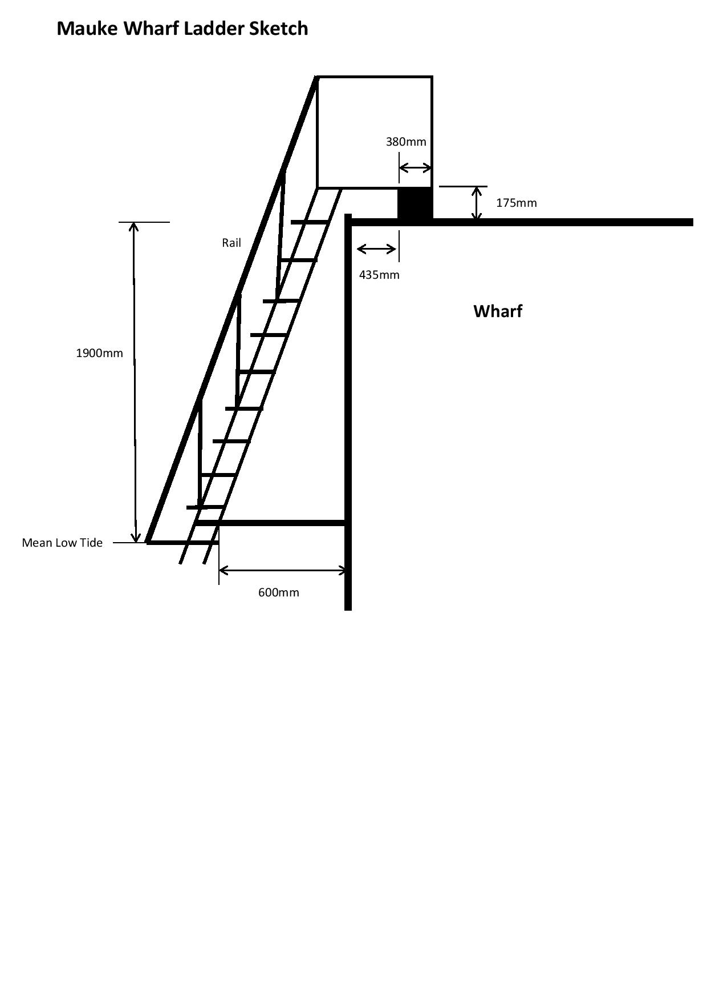

Aluminium Trolley

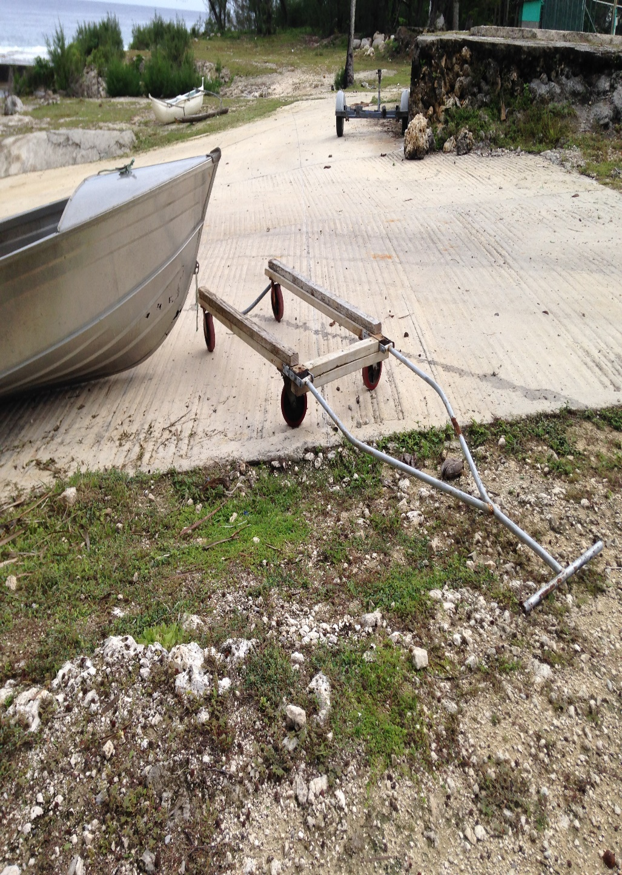

Attachment 2 – Tender Forms To Be Submitted

Instructions
1. Tenderers must complete and submit all the following forms, in the formats provided in this Attachment:
- A1 – Tender Form
- A2 – Conflict of Interest Declaration
- A3 – Completed Schedule of Prices
- A4 – Proposed Subcontractors (if applicable)
- A5 – Preliminary Delivery Programme
- A6 – List of Referees you may contact in relation to this offer.
2. Tenderers who fail to supply all the items listed in above, will be deemed non-compliant and will be excluded from the tender evaluation process.

A1 – Form of Tender
Climate Change Office
Office of the Prime Minister
Avarua
Rarotonga
COOK ISLANDS

Tender For: | Mauke Fishing Boats
Supplier: | [Name of supplier]

Having examined the Tender Documents in relation to Tender Reference No. ________ and dated __/__/__, released by The Office of The Prime Minister, we submit the following offer.
We offer to complete, handover to the Principal and remedy defects in the whole of the said Tender Specifications in conformity with these Tender Documents for the sum of [insert the price offered in text with the value in numbers thus (NZD$_________._)] stated exclusive of Value Added Tax, together with such other sums as may be ascertained in accordance with the Contract.
We acknowledge receipt of Notices __________ to __________.
We agree/do not agree to the Terms and Conditions of the Purchase Agreement in Attachment 4 of the said tender and do not propose any amendments.
We undertake to complete and handover of the whole of the Contract Works/Goods/Services within the period stated in the Conditions of Tendering.
We agree to abide by this Tender for a period of sixty (60) days from the date fixed for receiving the same and it shall remain binding upon us and may be accepted by you at any time before the expiry of that period.
Unless and until a Contract Agreement is prepared and executed, this Tender together with your written acceptance thereof, shall constitute a binding contract between us.
We understand that you are not bound to accept the lowest or any Tender you may receive.
We understand that no contract shall come into existence, and no legal or other obligations shall arise between us and you (or between us and any other agent of the Principal) in relation to the conduct, outcome or otherwise of the Tender process, prior to and apart from your acceptance of our Tender.
We understand that you may contact the referees nominated by us in this offer and make whatever enquiries you deem necessary regarding our financial health and ability to deliver the Contract Works/Goods/Services. Further, during the assessment stage we understand and agree that you may request specific information from all tenderers in order to assist your assessment. We acknowledge that a failure to provide such information may result in disqualification from the process.

We provide the following information required to be submitted with this Tender:
- A2 – Conflict of Interest Declaration
- A3 – Completed Schedule of Prices
- A4 – Proposed Subcontractors (if applicable)
- A5 – Preliminary Delivery Programme
- A6 – List of Referees you may contact in relation to this offer.
If the tenderer is unable to agree to any clauses included in the Conditions to the Contract, it must set out in a table form the clause reference, reason why the tenderer cannot accept it and proposed alternative wording.
Tenderers details:
Tenderers full name:
Tenderers trading name (if Company):
Contact person (if Company):
Postal address:
Physical address:
Phone number:
Mobile:
Email address:
Signature |  |  | Date
Full Name |  |  | Position (if Company)

A2 – Conflict of Interest Declaration

A conflict of interest arises if you or a close family member has an interest e.g. is a board or committee member or is employed in a senior position in the Government agency that wants to purchase the goods or services relating to this tender process.

In submitting this tender I declare:
- I understand that an actual, potential or perceived conflict of interest may arise in participating in this tender process and that I am obliged to declare any such conflict of interest.
- I confirm that in submitting this information that I have either declared any potential conflicts of interest or that I am not aware of any situation or issue that would conflict with the interest of the Principal.
- If a conflict of interest arises at any time before the selected supplier has been awarded, I will advise the Contact Officer or the Principal immediately.
- I have personally completed this declaration on behalf of the Supplier(s) and declare that the submitted tender bid provided are true and correct.

I declare that I have a potential conflict of interest as follows:

I will manage this conflict of interest by:
Declared by:
Signature |  | Date
Full Name |  | Position (if Company)

A3 – Completed Schedule of Prices
ITEM | DESCRIPTION | Unit | Qty | Rate | Cost
1 | 16-foot Aluminum Fishing Boat (open hull) | No. | 3
2 | A small central console steering facility or central side steering facility with the option to steer from the outboard motor | No. | 3
3 | Four rod holders roughly from midway to the front of the boat | No. | 12
4 | Flotation device as part of the construction of the boat | No. | 3
5 | Lifting handles on each side of the boat (one close to the front and one close to the back) to assist with manually moving the boat while on the ramp. | No. | 12
6 | Outboard motors | No | 3
7 | Boat trailer | No. | 3
8 | Towing ball coupler and safety chain | No. | 3
9 | Trailer Tongue Jack equipment | No. | 3
10 | Adjustable Jockey Wheel | No. | 3
11 | Bow guides | No. | 3
12 | Boat Winch, straps and accessories | No. | 3
13 | Tie down Straps gunwale, transom and bow straps | No. | 9
14 | Trolley as per photo | No. | 2
15 | Aluminum Ladder as per drawing | No. | 1
16 | Winch | No | 1
17 | Other requirements
18 | Freight and Insurances
19 | Literage and Transportation at Mauke
20 | Packaging, Crating, local cartage, customs duty and/or any other services in the delivery of the Materials
 | SUB TOTAL (NZD) (VAT exclusive)
 | VAT
 | TOTAL (NZD) (VAT Inclusive)

A4 – Proposed Subcontractors (if applicable)
Subcontractor details:
Subcontractors full name:
Subcontractors trading name (if Company):
Contact person (if Company):
Postal address:
Physical address:
Phone number:
Mobile:
Email address:
Works/Skills to be performed:

Educational/Technical Qualifications:

Work Experience:

Potential or Actual Conflicts of Interest:

A5 – Preliminary Delivery Programme
Provide your procurement and delivery schedule.

Details | Duration | Proposed Date of Action

A6 – List of Referees who may be Contacted

Name: | ________________________________________________________________
Company: | ________________________________________________________________
Address: | ________________________________________________________________
 | ________________________________________________________________
 | ________________________________________________________________
E-mail Address: | ________________________________________________________________
Phone No.: | ________________________________________________________________
Facsimile No.: | ________________________________________________________________
Nature of Relationship with Tenderer:

Name: | ________________________________________________________________
Company: | ________________________________________________________________
Address: | ________________________________________________________________
 | ________________________________________________________________
 | ________________________________________________________________
E-mail Address: | ________________________________________________________________
Phone No.: | ________________________________________________________________
Facsimile No.: | ________________________________________________________________
Nature of Relationship with Tenderer:

Attachment 3 – Evaluation Criteria
The Mandatory Conditions have been drawn from the Conditions of Tendering in this RFT. Tenders that do not meet the Mandatory Conditions are deemed non-compliant, and will not proceed into Evaluation.

Mandatory Conditions
Tenders must pass all the following requirements. Tenders that do not meet one or more of these conditions are deemed non-compliant and will not be considered.

Criterion | Complies  Yes or No
- Tender must be completed in the format contained in Attachment 2 of the RFT.
- Tenders must be deposited in the required form in the Tender Box by the closing time specified in the RFT
- Proposal and related documentation must be in the English language or translated into English.
- Tenderers must tender to provide the whole of the works/goods/services specified in the RFT.
- Tenders must be presented in hard copy and/or electronic copy format as specified in this RFT only.
- All prices quoted must be landed inclusive of freight and relevant charges to final point of delivery.
- All prices must be in NZ dollars

Evaluation Criteria
A Weighted Criteria methodology will apply to the evaluation of this RFT as follows:
Criteria | Weight  %
Non-Price Criteria
- Locally established company Locally supplied resources (labour and/or materials ) | 5
- Acceptance of the contract terms | 5
- Relevant skills | 10
- Past Performance | 5
- Quality of Materials | 20
- Resources available to complete Tender | 5
Total Non-Price Elements | 50
Price | 50
TOTAL WEIGHTING | 100

A Weighted Criteria methodology will apply to the evaluation of this RFT as follows:

Weighted Criteria | Score
Exceeds Requirements | 5
Satisfactory | 4
Meets Requirements with one minor “area of concern” | 3
Meets Requirements with several “areas of concern” | 2
Meets Requirements with major “areas of concern” | 1
Unsatisfactory | 0

The tenderer may provide additional documents or information to support their application
Evaluations will be conducted against the attributes outlined in the table above.

Risk
The Evaluation Committee will conduct a Risk Assessment for each Tender submitted. This will identify the most significant risks presented by the Tender and consider the likelihood of the risk occurring; the consequence of that risk; and a risk mitigation strategy. In conclusion, the mitigated risk will be determined to form an overall measure of the risk represented by each Tender.
The risk mitigation strategy may include the inclusion of specific clauses in the executed contract. Therefore, a Tender considered to be high risk might still be selected subject to the Tenderer’s willingness to accept the proposed contract amendments.

Attachment 4 – Contract Conditions

PURCHASE AGREEMENT
PURCHASE ORDER
Government: Her Majesty the Queen in right for the Government of the Cook Islands acting by and through the Office of the Prime Minister
Signed: _____________________________
Name: Bredina Drollett
Position: Chief of Staff, Office of the Prime Minister
Date:
Supplier:
Signed: _____________________________
Name:
Position:
Date:
___________________________________________________________________________________
Product and Services: Mauke Fishing Boats; The supply and delivery of Fishing Boats Trailers trollies, winch and ladder as per RFT 161730 to the Island of Mauke government storage yard.
Delivery: To the Mauke government storage yard by the Date……2017
Price: Price: NZD …………. to be paid in instalments as set out below:
Payment | Milestone | Percentage of total price | Amount
One | On signing of Contract | Fifty percent
Two | All Materials have landed in Mauke | Twenty-Five percent
Three | Materials have been delivered to Mauke Island local government storage yard and checked off by the Executive Officer. | Twenty-Five Percent
Insurance: All insurances covering indemnity and materials are fully covered by (successful tenderer) until the completion of this contract and the goods are delivered to the point of delivery.
Contact Person: Mauke Executive Officer
Government Contact: William Tuivaga
Supplier Contact:
Additional Terms: The supplier agrees that no changes will be made to the agreed quantities or quality of the materials and products supplied and no second hand, or used products will be supplied.

TERMS AND CONDITIONS FOR SUPPLY OF PRODUCT
The Supplier agrees to supply the Product described and detailed in the Purchase Order issued by the Government of the Cook Islands (the “Government”) on the following terms and conditions:
- APPLICATION
These terms and conditions apply to all purchases of Product except where the Government agrees in writing that they be varied or do not apply. These terms and conditions supersede any contrary provisions in the Supplier’s terms and conditions of supply including those terms that the Supplier normally uses. No right under these terms and conditions shall be deemed to be waived except by notice in writing by each party. In the event that any one or more of the provisions contained in these terms and conditions are declared invalid by an order, decree or judgment of any Court of competent jurisdiction, these terms and conditions will be read as if such provision had not been inserted.
- PRICES
  - The prices stated on the Government’s Purchase Order are fixed, unless there is a written agreement stipulating the price may be varied, when it may be varied and how the price is to be determined.
  - The price includes freight, insurance, packaging, crating, local cartage, customs duty and/or any other services in the delivery of the Product.
  - The price is exclusive of VAT.
  - The Supplier is not entitled to claim expenses, surcharges or margins or disbursements except if otherwise agreed in advance and in writing by the Government.
- DELIVERY
  - The time of delivery of the Product is a fundamental element of these terms and conditions.
  - The Product shall be delivered and rendered in a prompt and timely manner on or within the delivery dates specified in the Purchase Order. All Product must be delivered within the Government business hours (normal business hours are 8:00 am to 4:00 pm, Monday to Friday), unless otherwise specified in the Purchase Order.
  - The Supplier shall notify the Government in writing immediately when the Supplier becomes aware there may be a delay in the delivery of Product to the Government.
  - The Government is entitled to cancel the Purchase Order or change its specification (without incurring additional charges) if the Product is not supplied on the supply dates or times specified in the Purchase Order.
  - All Product must be supplied to the address specified in the Purchase Order. The Supplier shall make itself aware of any special requirements when supplying the Product to Government property.
  - When Product is delivered to the Government it shall be accompanied by a delivery docket that records the Purchase Order number, the description, quantity with the applicable units of measure, unit rates and dollar values of the Product delivered. The delivery docket must be signed for and retained by a Government officer.
  - All Product shall be packaged in a manner to prevent damage or deterioration when being delivered to the Government.
  - The Government may use other suppliers for the supply of Product, or product of the same nature as the Product, at any time.
- IDENTIFICATION
  - The Purchase Order number must be shown on all packages, invoices and correspondence relating to the Product. Product supplied against an invalid Purchase Order or without a Purchase Order, will be returned to the Supplier at the Supplier's expense including the cost of packaging, transportation, insurance and handling of the Product.
  - Where applicable, the Supplier grants the Government access to the Supplier’s premises, facilities and staff concerning the delivery and identification of the Product. The Government shall have the right to audit and inspect the Supplier’s records concerning delivery of the Product. These rights are for both the Government and any other party that has the use or benefit of the Product.
- QUALITY, INSPECTION AND ACCEPTANCE
It is a condition of these terms and conditions and the Supplier warrants that:
  - All Product shall be in accordance with any requirements set out in these terms and conditions and/or in the Purchase Order and shall be free from defects in workmanship, materials and design. These obligations survive acceptance of the Product and payment.
  - The Supplier shall use the highest reasonable standard of skill, care and quality and employ techniques, methods, procedures and materials of a high quality and standard in accordance with best professional practice in providing the Product.
  - The Supplier will comply with all relevant (a) Cook Island standards and international standards (if not in conflict) (both general and industry-specific); (b) statutes; (c) regulations; (d) by-laws; (e) ordinances; and (f) Government policies, applicable in respect of the supply of the Product.
  - Where the Supplier has the benefit of any warranties or covenants from a third party in respect of the Product, the Supplier shall disclose and assign the benefit of the warranties and/or covenants to the Government.
  - The Product, its material and workmanship, shall be subject to inspection and testing at all reasonable times and places by the Government (or those parties to whom the Government supplies the Product) before, during or after delivery.
  - If inspection and testing is to be conducted on the premises of the Supplier or the Supplier’s sub-contractors, the Supplier shall provide (without additional charge) all reasonable facilities and assistance for the safe and convenient inspection and testing required by the Government's inspectors in the performance of their duty.
  - The Supplier acknowledges that the signing of a delivery note or similar on behalf of the Government does not constitute acceptance of any Product. The Government may reject any Product, even after it has been accepted, that: (a) are not of merchantable quality; (b) are not fit for purpose as stipulated in the Purchase Order; (c) are in an unsatisfactory condition or not functioning in the way they are designed to function; or (d) do not otherwise meet the requirements (including requirements relating to delivery) of these terms and conditions, ("Rejected Product").
  - For any Rejected Product, the Supplier will, within ten (10) business days of receiving notice of Government's rejection of the Rejected Product, at the Government's sole and absolute discretion and at the Supplier's sole risk and expense: (a) repair the Rejected Product; (b) replace the Rejected Product; (c) remove the Rejected Product for full credit or reimbursement.
  - Title to the Rejected Product will pass back to the Supplier on the earlier of the replacement of the Rejected Product or, refund or credit of any amounts paid by the Government as specified in clause 5.8(c).
  - Clauses 5.7 and 5.8 do not limit or negate any other rights or remedies that the Government may have under these terms and conditions or at law.
  - The Government’s failure to inspect does not relieve the Supplier of any responsibility to perform its obligations according to these terms and conditions.
- OWNERSHIP AND RISK
  - Subject to clauses 5.7 and 5.8:
    - Title in the Product passes to the Government when the Product is delivered to the Government or when the Government completes payment for the Product, whichever is the earlier date;
    - The Product remains at the Supplier’s risk until the Product is delivered to the Government.
  - Where the Product is delivered to the Government to be installed and/or commissioned, the Product remains at the Supplier’s risk until the completion of installation and commissioning.
- PAYMENT
  - The Supplier shall provide to the Government’s Contact Person, within five (5) business days of the end of the month following delivery of the Product, a VAT tax invoice for each delivery of the Product, stating Purchase Order number, date of delivery and full description of the Product and quantity delivered. Invoices received without all of these details will be returned to the Supplier, unpaid.
  - If monthly charges are applicable, the Supplier shall supply to the Contact Person specified in the Purchase Order a monthly statement of that month’s deliveries not later than the tenth business day of the month following delivery.
  - Invoices and statements are to be addressed to the address specified in the Purchase Order.
  - Subject to clause 5, payment for Product delivered, once accepted, will be effected on the first Wednesday on or after the 20th of the month following the date of the Supplier’s VAT tax invoice or receipt of the delivery of the Product, whichever is the later.
  - Any invoices provided by the Supplier which have not met the requirements of this Payment clause will not be effected.
  - Payment will be effected by Electronic Funds Transfer (EFT) (direct credit).
- CONFLICT
  - The Supplier confirms it has no knowledge of any conflict of interest in providing the Product.
  - If any conflict arises or has the potential to arise during the supply of the Product, the Supplier shall immediately inform the Government in writing and the Government will decide on the appropriate steps to be followed in such event, which may include the right of the Government to terminate the Purchase Order with immediate effect.
- ASSIGNMENT
The Supplier must not assign, transfer or sub-contract any rights or obligations applicable under these terms and conditions without the prior written consent of the Government, such consent to be given at the Government’s absolute discretion.

- NOTICES
  - All correspondence shall include the Purchase Order number and addressed to the Government’s Contact Person named on the Purchase Order form.
  - All correspondence shall be in writing sent by email, mail with postage prepaid or by hand delivery to the address for notices as set out above or such other address as a party has notified in writing.
  - Subject to clause 10.4, notice given in person is deemed to be served upon delivery or by post three (3) business days after the date of posting. Any notice served on a non-business day is deemed to have been served on the first business day after that day. Any notice by email shall be deemed to be received on the first business day after such email has reached the receiver’s designated information system for receiving emails or, in all other situations, when the email comes to the receiver’s attention.
  - The Government shall only be deemed to have received delivery of a notice upon the Government acknowledging in writing receipt of the notice.
- INDEMNITY
The Supplier indemnifies the Government in respect of all costs (including legal costs), claims, liabilities, losses, damage and expenses suffered or incurred by the Government and any other person claiming through the Government as a direct or indirect consequence of any unlawful, negligent, tortious, criminal, reckless or dishonest errors, acts or omission of the Supplier in the performance of its obligations under these terms and conditions. This indemnity survives the termination of these terms and conditions.
- REMEDIES
The Supplier shall not be entitled to anticipatory profits or to special (including multiple or punitive), incidental or consequential damages or losses.
- INSURANCES
  - The Supplier shall take out and maintain at its own cost, at all times during the continuance of these terms and conditions, such insurances as specified in the Purchase Order. All such insurance shall be on such terms and with such insurers as the Government may reasonably require.
  - The Supplier shall, if requested by the Government, provide the Government with written evidence that all insurances are in force and shall produce, whenever reasonably required by the Government, the relevant policies and evidence of payment of the current premiums. If the Supplier fails to provide such evidence the Government may, after notifying the Supplier in writing, arrange or keep in force that insurance and may, for the purpose of doing so, pay the relevant premiums and deduct a corresponding amount from any moneys payable by Government to the Supplier under these terms and conditions.

- LAW
These terms and conditions are governed by the laws of the Cook Islands. The parties agree to submit to the exclusive jurisdiction of the High Court of the Cook Islands.
- TERMINATION FOR CONVENIENCE
Notwithstanding anything to the contrary contained in these terms and conditions, the Government shall be entitled to cancel any applicable Purchase Order, at its convenience, on 10 days' written notice to the Supplier; provided the Government will pay for all Product delivered to the satisfaction of the Government in respect of any Purchase Order, prior to the date of notice of cancellation.
- GENERAL WARRANTIES
The Supplier represents, warrants and undertakes that:
  - it has full power, capacity and authority to execute, deliver and perform its obligations under these terms and conditions or any Purchase Order;
  - it has and will continue to have, all necessary consents, permissions, licences and rights to enter into and perform its obligations under these terms and conditions or any Purchase Order;
  - there are no existing agreements, undertakings or arrangements which prevent it from entering into these terms and conditions or which would impede the performance of its obligations under these terms and conditions or any Purchase Order;
  - it has not offered any inducement in connection with the entering into or negotiation of these terms and conditions or any Purchase Order and;
  - it has not (nor is any of its representative directors or employees) a party to any litigation, proceedings or disputes which could adversely affect its ability to perform its obligations under these terms and conditions or any Purchase Order.
17. DISPUTE RESOLUTION
In the event of a dispute arising between the parties in respect of any matter in relation to this Agreement, the authorised representatives of each party will negotiate a resolution. If the dispute cannot be resolved by negotiation within five days of service by one party to the other of the written notice of a dispute arising, the dispute will be referred to arbitration under the Arbitration Act 2014.

