Appendix 1: Additional and Available Information/Technical Specifications
The following technical informations compiled for each project site is derived from the ADB PPTA-8439-COO: Renewable Energy Project; Contract No.: 108080-S52216. Copy of the full report is available from REDD Office on request.
PROJECT SITE 1: Mitiaro Island
Mitiaro (pop. 189) with a surface of 22 kmq. It belongs to the local group of island that includes Mauke (the closest island only 10 minutes flight time from it), Atiu and Takutea. It is 47 km a north-west of Mauke and 39 km a south-east Atiu
Main economic activities consist of a small store located in the center of the main village. There are small productions of fruit and vegetables. Fishing, together with pigs and chicken free range, complete the economic activity and provide the source of protein to Atiu's people.
Infrastructural system of the island: the island has a road system completely unpaved. Roads are in a general good condition. The airport has a non paved runway that allow regular connection service with the island of Rarotonga operated by Air Rarotonga's Embraer EMB-110 Bandeirante, a general purpose 15-21 passenger twin-turboprop, light transport aircraft, used for passenger and small cargo transportation. Served 3 times a week and ingoing flights make a stop in Mauke.
The island has a small port that limits the maximum weight of goods to be landed to 5 tons. Landing occurs by a barge that shuttles between the ship offshore and the harbor. It is generally used to land small fuel tanks that contain petrol or diesel, both for car and for supplying the local power station. Regular connections are assured with Raratonga port by Taio Shipping, a local shipping corporation that is operational both in the southern and northern island groups with 2 vessels: Lady Moana, a 163 tons general cargo vessel built in 1997 and Maungaroa II, a 154 tons general cargo built in 1978. The limitation of port maximum landing capacity to 5 tons must lead to think about battery and storage containerized system far from the standard 20 or 40 feet traditional size.
The island has a local power station with only low voltage three phase distribution system with adequate cable size that allow to keep low power losses in the distribution feeders and with a low voltage drop figure. The grid anyway will require maintenance since many pillar boxes show burned or rusted contacts and circuit breakers, in some cases also no longer operational. The detailed specifications are described in detail within this report.
In addition to these infrastructures, the island has a Cook Telecom station with internet Wi-Fi hotspots in the center of the village, hospital and school, in addition to churches catholic and protestant. It is important to note that churches, like in other islands, do not pay electricity.
Community contacts and capacity of staff: as seen in other islands the team had contact with the local council that is managing the power and other public services. The council showed a high degree of cooperation with the team and allowed also a good interaction with the personnel responsible for power station operation. Although the photovoltaic system normally do not require particular maintenance it's important to give to the local staff the appropriate knowledge to manage its operation. This means taking care about keeping the panels free from dust and from birds' guano. Training would also include the appropriate information to be given to the people that will be responsible for the operation of the system so that they could be ready to face eventual faults. The program will consider providing spare parts to each island so to ensure fast replacement of most important components. The local personnel should be properly trained in order to be able to operate this replacement and to keep the system fully operational.
Existing Informations
The government data refer to a population of 189 with total household of 145. the reported maximum demand is calculated at 38 kW with a total installed capacity of 77 kW.
Mitiaro’s electricity grid has an underground network accessed via pillar boxes and two sections of overhead lines. The entire network runs at low voltage (415V, 50 Hz, 3 phase) there are no medium voltage distribution grids also if there are a couple of unused step up transformers close to the power station, nobody knows about their presence. There are two main feeders from the power station – Atai feeder, running north along the coast road, and Takuae feeder, running south along the coast road. There are two inland overhead lines, the longer being the Hospital line.
In previous studies the voltage network is rated at 240V, 50 Hz, 3 phase. That value is non coherent with similar island low voltage side distribution systems. Normally in fact the three phase distribution system is at 400V (in Europe) or 415V in all countries that adopted the British voltage standards like all Cook Island. So it is really unlikely that Mitiaro adopted a 240 V three phase system where all alternators are normally designed for operation at 400V or 415V three phase systems. The 240 V that derives from this distribution system has therefore to be considered only as single phase system derived from the three phase, phase to neutral connection, whose ratio is the phase to phase voltage divided by square root of 3.
The previous reports talk about the Island Council desire to extend the electricity network to the airport to supply power to Air Rarotonga’s office there, and also to supply new houses along the airport road.
All studies regarding Mitiaro talk about a grid that needs renewal and extension.
Assessment of Power Generation System
Diesel Gensets
It consists of a relatively modern Genset from a Japanese company called Denyo with 45kW and an old Deutz which was said to have 22-28kW (the name plate of the alternator says 56kWA/44.6 kW). Both gensets are in relative poor condition with leaking oil and emission gases. The diesel power plant is managed by Mr. Kimiora Maara (+68276934).

A central plant management does not exist. It is not possible to operate the gensets in parallel. This means that there is always a short black-out during the switching process from one genset to the other. This happens twice a day. Peak load is experienced during Christmas time and can reach up to 50kW resulting in an overloading of the genset. In the morning the average load is around 40kW. Service is conducted every second week and includes an oil exchange (13l Lister, 15l Denyo). The plant consumes 3200 l/month.
It is recommended that the gensets will be replaced during the renewable mini-grid project by two gensets of the size of 60kW and an automated plant management system which will be able to communicate with the renewable hybrid system.

Deutz | 22kW -28kW | 2009
Denyo | 45kW | 2010

Demand Side
The load of Mitiaro is dominated by domestic consumers having their largest energy consumption in the morning and evening. A few months ago it was even usual to shut down the power plants from 0 AM to 5 AM for fuel saving reasons. Currently they switched to constant power supply which also leads to constant loads.
The energy consumption peaks during summer months (December to January) when the most visitors, mostly family members, are on the island for Christmas holidays. The annual production of electricity is 206 MWh for Jul 2012 to June 2013. Monthly values are taken from the electricity reports.
Month | Gross Diesel Generation (kWh)
Jul-12 | 16,720
Aug-12 | 15,600
Sep-12 | 18,855
Oct-12 | 13,780
Nov-12 | 14,900
Dec-12 | 19,260
Jan-13 | 20,540
Feb-13 | 16,700
Mar-13 | 18,060
Apr-13 | 17,640
May-13 | 17,480
Jun-13 | 16,600
FY 2013 | 206,135

By onsite measurements the daily profile of October the 10th has been assessed. Originally it was peaking at 2 PM, but this peak has been flattened as it was caused by an unusual extra consumption (cooking for island feast). These values have been taken to create an hourly and yearly load profile as shown in Figures 1 and 2.
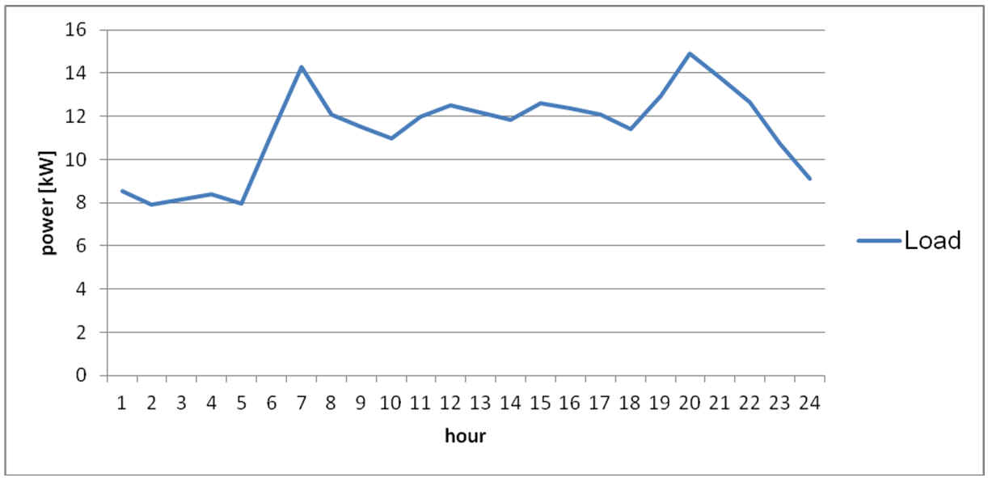
Figure 1: Daily production profile of Mitiaro (10/30/13) – flattened

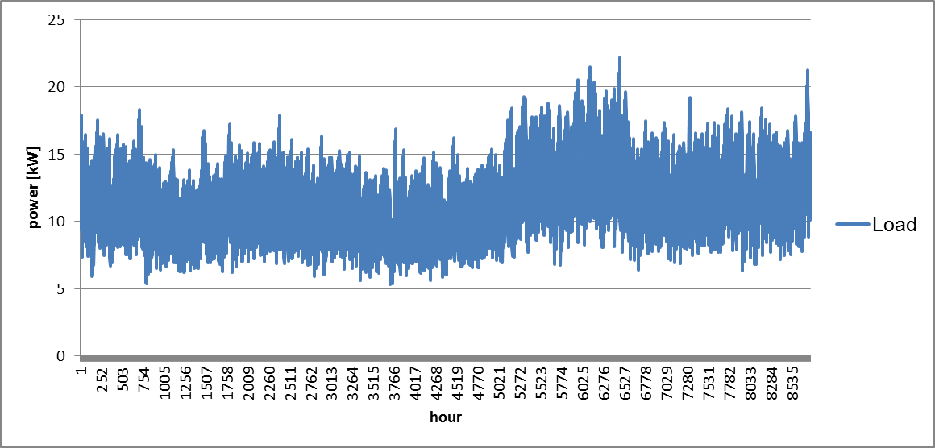

Figure 2: Synthetic annual production profile of Mitiaro
Demand projections are difficult for Mitiaro. Some new buildings are planned and due to 24 hrs of electrification a higher consumption is expected. For the simulation the load profile is scaled up by 20 %.

PROJECT SITE 2: Mauke Island
Mauke (pop. 310) is half the size of Rarotonga in circumference (18 kms, 11.25 miles) with a surface of 20,3 kmq. It belongs to the local group of island that includes Mitiaro (the closest island only 10 minutes flight time from it), Atiu and Takutea. Its central volcanic plateau is surrounded by ring of jagged fossilized coral or makatea which reaches up to 1,000 metres inland. But the volcanic origins mean the soil is rich and this is justifiably called the garden of the islands.
The island is divided into four districts - Ngatiarua, Vaimutu, Areora and Makatea - two of which are split into their own sub-districts.
Main economic activities consist of small stores located in the center of the main village. There are small productions of fruit and vegetables. Fishing, together with pigs and chicken free range, complete the economic activity and provide the source of protein to Mauke’s people.
Infrastructural system of the island: the island has a road system paved only in the center of the village. Roads are in a general good condition. The airport has a non paved runway that allow regular connection service with the island of Rarotonga operated by Air Rarotonga's Embraer EMB-110 Bandeirante, a general purpose 15-21 passenger twin-turboprop, light transport aircraft, used for passenger and small cargo transportation.
The island has a small port that limits the maximum weight of goods to be landed to 5 tons. Landing occurs by a barge that shuttles between the ship offshore and the harbor. It is generally used to land small fuel tanks that contain petrol or diesel, both for car and for supplying the local power station. Regular connections are assured with Raratonga port by Taio Shipping, a local shipping corporation that is operational both in the southern and northern island groups with 2 vessels: Lady Moana, a 163 tons general cargo vessel built in 1997 and Maungaroa II, a 154 tons general cargo built in 1978. The limitation of port maximum landing capacity to 5 tons must lead to think about battery and storage containerized system far from the standard 20 or 40 feet traditional size.
The island has a local power station and both high voltage and low voltage distribution system. The detailed specifications are described in detail within this report.
In addition to this infrastructure, the island has a Cook Telecom station with internet Wi-Fi hotspots in the center of the village, hospital and school, in addition to churches catholic and protestant. It is important to note that churches, like in other islands, do not pay electricity.
Community contacts and capacity of staff: as seen in other islands the team had contact with the local council that is managing the power and other public services. The council showed a high degree of cooperation with the team and allowed also a good interaction with the personnel responsible for power station operation. Although the photovoltaic system normally do not require particular maintenance it's important to give to the local staff the appropriate knowledge to manage its operation.
This means taking care about keeping the panels free from dust and from birds' guano. Training would also include the appropriate information to be given to the people that will be responsible for the operation of the system so that they could be ready to face eventual faults. The program will consider providing spare parts to each island so to ensure fast replacement of most important components. The local personnel should be properly trained in order to be able to operate this replacement and to keep the system fully operational.
Review of Existing Studies
The location of the island of Mauke is very close to the other same sized island of southern group Mitiaro, and shares the same electrical requirements. The distribution network is with a 3,3 kV underground feeder and low voltage overhead distribution system.
Except for the small store equipped with refrigerators, the loads are mainly residential and energy is produced by Diesel generators, just like other smaller and bigger islands. In this case the need to reduce the dependence of this island from fossil fuel for energy production is essential also considering that Diesel fuel will always increase.
Normally water pumping during the day is supplied by a local photovoltaic system, but it can also happen that this pumping is operational also in the night so that the power consumption occurs also in off-peak hours. This will be carefully analyzed since a reduction of the amount of night energy will require smaller battery capacity, resulting in a cheaper and longer life storage system.
According to census and from power utility council data from 2011 there are approximately 310 permanent residents on the island. The population increases during major holidays or island events (such as Christmas and Easter) when many non-resident Maukeans return to the island. Island administration billing data showed 194 power accounts, of which 146 were still active as at April 2013.
The measurements on Mauke grid show an average power 25 to 30 kW with a peak value of 35 kW.
No detailed records are available to ascertain load growth, comparison with the Mauke Power Sector Report 2004 (Clay, 2004) shows a reduction in monthly electricity consumption since 2004.
Assessment of Power Generation System
Diesel Gensets
Mauke has four diesel generators. The total installed capacity is 214kW (see table below). The system is in very poor condition. All gensets use mechanical speed governor. The AVR are electronic devices. Genset 2 is overheating and is only used as standby. The power plant is managed by Mr. Arapo Tutai (+682 73044).
The plant has no automated plant management system. Gensets are brought online manually. It takes a lot of experience and time to synchronize gensets. It was reported that there are power outages due to the incorrect switching during the synchronization process. Other reasons for blackouts are water in the fuel. There are blackouts from one per week to one per month. The genset operates in droop mode. The frequency is adjusted manually to keep it around 50Hz. A second genset will be brought online once the load has reached 50kW. This happens usually from 6-7am and from 6-9pm. Once a month a service is conducted where the lubrication oil and filter are changed.
The island council plans to move the powerhouse to a central side on the island close to the proposed PV site. It is recommended that the genets will be replaced by two 60kW new generators with an electronic plant management system, which is able to communicate with the coming renewable energy system. The size is big enough to cover the peak demand. Two gensets are needed to be able to service one genset while the other one is available. The gensets will only act as backup system and will be off-line most of the time.

 | Model | Engine/Generator | Power (kVA/kW) | Year
Nr. 1 | Deutz | Deutz/Stamford | -/58 kW | 2009
Nr. 2 | Lister | Lister/Stamford | -/58 kW | 2003
Nr. 3 | Lister | Lister/Stamford | -/40 kW | 2003
Nr. 4 | Deutz | Deutz/Stamford | -/58 kW | 2009

The fuel is stored in two day-fuel tanks with 2x227l capacity. Further capacities are 2x3640l tanks and the fuel cubes which are used to transport the fuel from the vessel to the plant (7x1600l). Diesel fuel is shipped once a month. The annual fuel consumption is in the range of 155,000l/a.
Demand Side
The load of Mauke is dominated by domestic consumers having their largest energy consumption in the evening. Beside households a few shops and bars exist, but having no major influence on the load profile.
The energy consumption peaks during summer months (December to January) when the most visitors and tourists are on the island for Christmas holidays. The annual production of electricity is 206 MWh for Jul 2012 to June 2013. Monthly values are taken from the electricity reports.

Month | Gross Diesel Generation (kWh)
Jul-12 | 16,720
Aug-12 | 15,600
Sep-12 | 18,855
Oct-12 | 13,780
Nov-12 | 14,900
Dec-12 | 19,260
Jan-13 | 20,540
Feb-13 | 16,700
Mar-13 | 18,060
Apr-13 | 17,640
May-13 | 17,480
Jun-13 | 16,600
FY 2013 | 206,135

From the automatic data logging system at the power plant 10 minutes logs of electricity production are extracted for the week from the 15th to the 22nd of August 2013. These values have been taken to create an hourly load profile for one year by adjusting it to the monthly values of Figures 1 and 2,where the weekly and annual load profile (measured at the production site) of Mauke are shown.
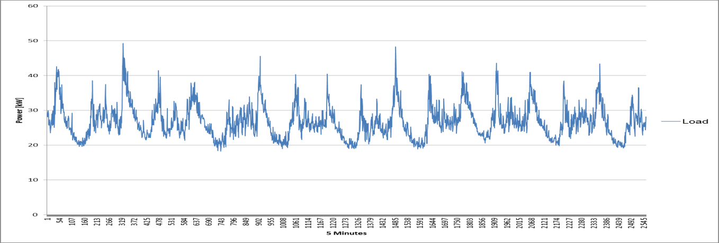
Figure1: Weekly production profile of Mauke (15/08/13 to 22/08/13)
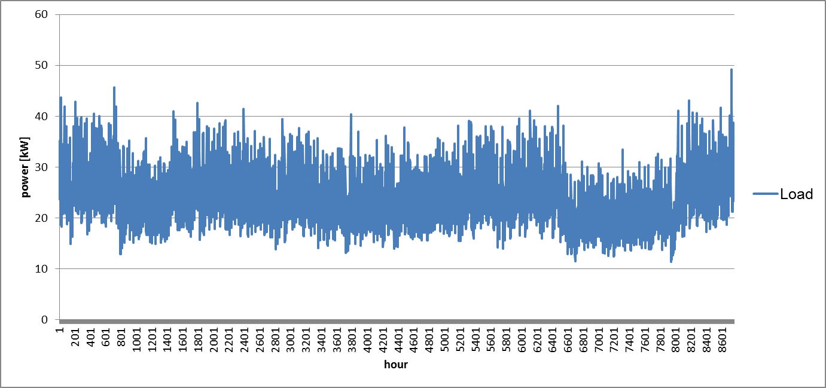
Figure 2: Synthetic annual production profile of Mauke
Demand projections are pretty conservative for Mauke. No significant construction projects are planned and almost all households are grid connected. It is therefore expected that the electricity demand remains stable for the next years.

PROJECT SITE 3: Mangaia Island
Mangaia (pop. 573) with a surface of 51,8 kmq. It is located 177 km southeast of Rarotonga. The capital is the village of Oneroa, on the west coast, containing about half the population. There are two more villages, Tamarua in the south and Ivirua in the northeast.

Main economic activities consist of small stores located in the center of the main village and in other two villages. There are small productions of fruit and vegetables. Fishing, together with pigs and chicken free range, complete the economic activity and provide the source of protein to Atiu's people.
Infrastructural system of the island: the island has a road system completely unpaved. Roads are in a general good condition. The airport has a non paved runway that allow regular connection service with the island of Rarotonga operated by Air Rarotonga's Embraer EMB-110 Bandeirante, a general purpose 15-21 passenger twin-turboprop, light transport aircraft, used for passenger and small cargo transportation. Served only once a week.
The island has a small port that limits the maximum weight of goods to be landed to 5 tons. Landing occurs by a barge that shuttles between the ship offshore and the harbor. It is generally used to land small fuel tanks that contain petrol or diesel, both for car and for supplying the local power station. Regular connections are assured with Raratonga port by Taio Shipping, a local shipping corporation that is operational both in the southern and northern island groups with 2 vessels: Lady Moana, a 163 tons general cargo vessel built in 1997 and Maungaroa II, a 154 tons general cargo built in 1978. The limitation of port maximum landing capacity to 5 tons must lead to think about battery and storage containerized system far from the standard 20 or 40 feet traditional size.
The island has a local power station with 11 kV high voltage three phase underground distribution system with adequate cable size that allow to keep low power losses in the distribution feeders and with a low voltage drop figure. The grid is in good condition and pillar box are put under every street light. The detailed specifications are described in detail within this report.
In addition to such infrastructure, the island has a Cook Telecom station with internet Wi-Fi hotspots in the center of the village, hospital and school, in addition to churches catholic and protestant. It is important to note that churches, like in other islands, do not pay electricity.
Community contacts and capacity of staff: as seen in other islands the team had contact with the local council that is managing the power and other public services. The council showed a high degree of cooperation with the team and allowed also a good interaction with the personnel responsible for power station operation. Although the photovoltaic system normally do not require particular maintenance it's important to give to the local staff the appropriate knowledge to manage its operation. This means taking care about keeping the panels free from dust and from birds' guano. Training would also include the appropriate information to be given to the people that will be responsible for the operation of the system so that they could be ready to face eventual faults. The program will consider providing spare parts to each island so to ensure fast replacement of most important components. The local personnel should be properly trained in order to be able to operate this replacement and to keep the system fully operational. The well skilled technician in charge of running the island's system will ease this task.

Review of Existing Studies
The government data back to 2011 refer to a population of 573 with total household of 177. the reported maximum demand is calculated at 120 kW with a total installed capacity of une unit for 330 kW power. In the meantime the power station has been renewed and now the power station had 4 new units. Wit a rated tariff of 54cents/kWh for domestic users and 74 cents/kWh per commercial plus 12,5% VAT.
A pre-feasibility study for Mangaia, undertaken by Southern Perspectives in October 2012, found that PV mini-grids are feasible for Mangaia and this design report builds on the analysis completed in that report. Mangaia’s relatively large load size necessitates an unusual approach to the PV mini-grid design – two separate mini-grids are required to supply the island’s existing loads. A total PV capacity of approximately 594 kWp with 16 clusters is required and it is proposed that this be split into two systems of approximately 297 kWp with 8 clusters each.
Reports have computed the electricity consumption data billing records and power station records, not always these reports cross-checked these information in order to obtain a quantification of the system power loss figure. Like most other small islands it's possible to see significant month-to-month variation in electricity consumption, the peak consumption is seen in December and January. This is due to the return of resident Mangaians for holidays or family events, and this occurs generally Christmas and Easter.
Report written by independent consultants refer to a load profiles obtained from the generator control system at the Mangaia power station, they confirm that these data are to be considered reliable and accurate. On the base of these data it appears that daily peak occurring in the evenings, typically at 19:00 – 20:00. There is also a morning peak which is influenced by a bakery which usually operates in the mornings. Generator log data shows a typical daily peak of approximately 100kW, with the highest peak for the year being 168 kW in December/January.
Studies show that load are substantially constant during past 5 years. On one side there is an increase in the usage of domestic appliances, this is balanced by the decrease of population.

Assessment of Power Generation System

Diesel Gensets
The diesel power plant, grid infrastructure and water supply system of Mangaia is managed by an Australian Anthony White (mangtv@mangaia.net.ck). He is partially involved in the planning of the power supply of the other islands.

Mangaia has three modern diesel generators, which were installed in in 2009 and 2012. The total installed capacity is 432kW (see table below). They are in very good condition. The gensets were assembled by the Turkish company aska Ltd and are of similar type using Cummins engines and Stanford alternator.

The plant management system was implemented by Greenbird Technology, which has also installed the systems on Aitu and currently in Rarotonga. The fuel efficiency of the plant has an average of 3.1 kWh/l

 | Model | Engine | Power (kVA/kW) | Year
Nr. 1 | aksa AC 200 | Cummins 6 CTA 8.3-G2 | 180/144 | 2009
Nr. 2 | aksa AC 200 | Cummins 6 CTA 8.3-G2 | 180/144 | 2009
Nr. 3 | aksa AC 200 | Cummins 6 CTA 8.3-G2 | 180/144 | 2011

The fuel is stored in two fuel tanks with 2x16.000l capacity. They are refilled once a month. The annual fuel consumption is in the range of 155.000l/a.

System Design PV-Battery-Diesel Plant

Batteries
System Design: The argumentation regarding the chosen battery technology and housing concept are described in the central report. The proposed storage technology for Mangaia is based on Lithium ion battery cells. The result of the simulation study proposed an energy storage system of the size:
Power: 140kW
Capacity: 1000kWh (installed capacity at 80% depth-of-discharge)

This system size can be fitted into three 20” containers including battery inverter, central PV inverter, battery racks and air conditioning systems.

Energy Management System
The energy management system will be the central device responsible for the seamless operation of the two systems. It will decide and communicate when to bring a genset online and when to switch it off. The decision will be taken based on the state-of-charge and the general availability of the storage system. The system must also be able to communicate to the PV plant and limit the feed-in power e.g. when the battery is full.
The existing thermal plant management system from ComAp a.s. seems to be suitable to communicate with a potential renewable energy systems. Further details must be clarified during the implementation-planning phase.

Location
It is advised that the energy storage system is located close to the powerhouse where enough space for three containers is available. This will allow a short connection to the plant management system for the communication and the bus bar of the gensets to transfer the power.

Electrical Connection
The connection of the hybrid system must be assessed in detail during the implementation phase. There are two alternatives to couple the system to the existing island grid:
1. Direct coupling to the genset bus bar (it needs to be determined if an isolating transformer is needed)
2. Coupling via a HV transformer to the HV lines
The grid or diesel bus-bar connection must be evaluated and planned during the detailed design phase.

Transport
The landing of a 20” Container is a challenging task but possible. In discussion with Mr. Malcom Sword (director of transport) it was conclude that a 20” container with a maximum weight of 5 tones in total can be landed on Mangaia. The barge from Aitutaki is needed to transport the container from the vessel to the wharf since the local barge is not able to carry 20” containers. To move the container on land a 12 tones excavator . The battery cells/trays must be shipped separately due to UN transportation regulation. So it should be possible to keep the weight within this limit even if parts of the system must be dismantled temporarily.

Demand Side

The load of Mangaia is dominated by domestic consumers having their largest energy consumption in the morning and evening.

The energy consumption peaks during summer months (December to February) when the most visitors are on the island for Christmas holidays. The annual production of electricity is 206 MWh for Jul 2012 to June 2013. Monthly values are taken from the electricity reports.

Month | Gross Diesel Generation (kWh)
Jul-12 | 38,708
Aug-12 | 40,450
Sep-12 | 36,516
Oct-12 | 38,316
Nov-12 | 38,908
Dec-12 | 41,965
Jan-13 | 41,561
Feb-13 | 34,728
Mar-13 | 41,186
Apr-13 | 36,462
May-13 | 37,437
Jun-13 | 35,148
FY 2013 | 461,385
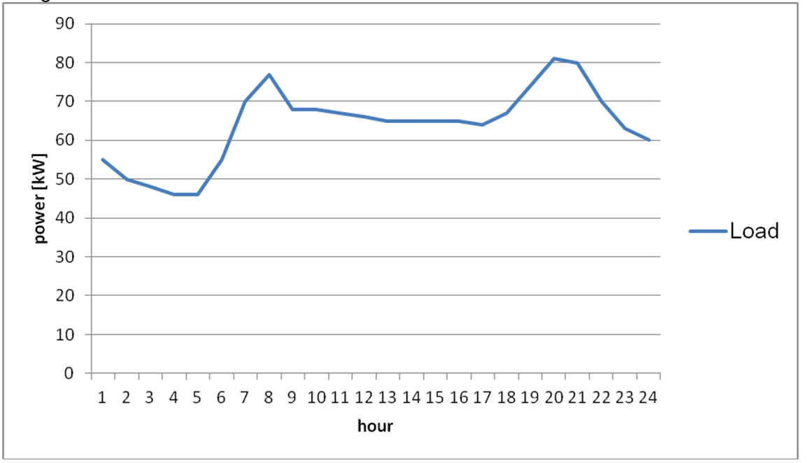
From measurements at the power plant a daily production profile has been derived. These values have been taken to create an hourly load profile for one year by adjusting it to the monthly values of Figures 1 and 2. There, the weekly and annual load profile (measured at the production site) of Mangaia is shown.

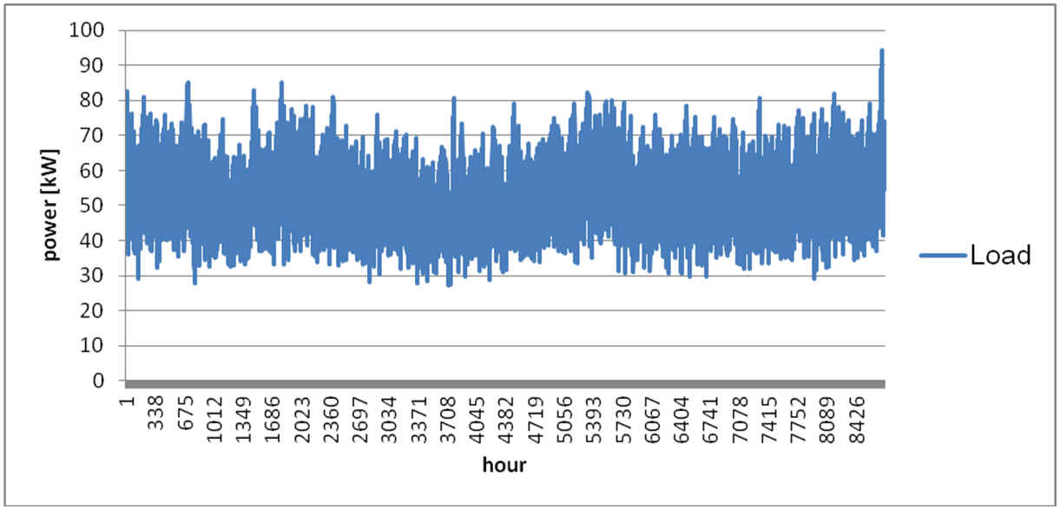
Figure1: Daily production profile of Mangaia (10/17/2013)

Figure 2: Synthetic annual production profile of Mangaia
Demand projections are pretty conservative for Mangaia. No significant construction projects are planned and almost all households are grid connected. It is therefore expected that the electricity demand remains stable for the next years.

PROJECT SITE 4: Atiu Island
Atiu (pop. 480) is an island belonging to the southern group of Cook Island. Its surface is 27kmq and it is located at 187 km north east of Rarotonga.
Main economic activities consist of a small production of coffee which fruits are roasted on site by roaster that represents the largest commercial load on the island. Other important economic activity is the resort called Villas and it has been created by a foreigner entrepreneur in 1978. Other meaningful commercial activities are stores located in the center of the main village. There are also small productions of pineapples and other fruit and vegetables. Fishing, together with pigs and chicken free range, complete the economic activity and provide the source of protein to Atiu's people.
Infrastructural system of the island: the island has a road system paved only in the center of the village. Roads are in a general good condition. The airport has a non paved runway that allow regular connection service with the island of Rarotonga operated by Air Rarotonga's Embraer EMB-110 Bandeirante, a general purpose 15-21 passenger twin-turboprop, light transport aircraft, used for passenger and small cargo transportation.
The island has a small port that limits the maximum weight of goods to be landed to 5 tons. Landing occurs by a barge that shuttles between the ship offshore and the harbor. It is generally used to land small fuel tanks that contain petrol or diesel, both for car and for supplying the local power station. Regular connections are assured with Raratonga port by Taio Shipping, a local shipping corporation that is operational both in the southern and northern island groups with 2 vessels: Lady Moana, a 163 tons general cargo vessel built in 1997 and Maungaroa II, a 154 tons general cargo built in 1978. The limitation of port maximum landing capacity to 5 tons must lead to think about battery and storage containerized system far from the standard 20 or 40 feet traditional size.
The island has a local power station and both high voltage and low voltage distribution system. The detailed specifications are described in detail within this report.
In addition to these infrastructure, the island has a Cook Telecom station with internet Wi-Fi hotspots in the center of the village, hospital and school, in addition to churches catholic and protestant. It is important to note that churches, like in other islands, do not pay electricity.
Community contacts and capacity of staff: the team had contact with the local council that is managing the power and other public services. The council showed a high degree of cooperation with the team and allowed also a good interaction with the personnel responsible for power station operation.

Although the photovoltaic system normally do not require particular maintenance it's important to give to the local staff the appropriate knowledge to manage its operation. This means taking care about keeping the panels free from dust and from birds' guano. Training would also include the appropriate information to be given to the people that will be responsible for the operation of the system so that they could be ready to face eventual faults.

The program will consider providing spare parts to each island so to ensure fast replacement of most important components. The local personnel should be properly trained in order to be able to operate this replacement and to keep the system fully operational.
Review of Existing Studies
According to data released in 2012 the total installed power in the island is 242 kW and it is supplied by a single diesel generator feeding a overhead medium voltage line at 3,3 kV. The maximum demand of the grid is calculated in 100 kW.
Tariff is 0.48 NZ$ per kWh for residential and 0.68 NZ$ for commercial (plus VAT at 12,5%, which it is expected to rise at 15% rate shortly)
The most recent study issued by Itp in late 2013 reports the same conditions that the team found on the Atiu island: 4 diesel units ranging in size from 63 kVA to 180 kVA new and in good condition since installed in 2012, Greenbird generator control system which automatically selects and synchronizes generators in response to the load. The IT power mini-grid system design proposes re-use of the existing generators after the PV system is installed and integration of the PV component with the generator control system.
The proposed system design has been based on the Mini-Grids Common Design Principles (Wade 2012) document provided by MFAT and includes the following components:
396 kWp crystalline solar panels
576 x sealed lead acid batteries rated at 3,500Ah at C20
36 x Sunny Island 8.0H inverter chargers
48 x Sunny Boy SB5000TL string inverters
48 x SIC 50 charge controllers
At least 2 of the existing generators to be retained and kept operational at all times.
A preliminary cost estimate indicates that the proposed system would cost approximately NZD $3.2 million. Preliminary economic analysis shows the Levelized Cost of Energy (LCOE) for the system operating and replacement costs only (assuming that capital costs are paid by a donor) to be $0.72 / kWh, compared to $0.87 /kWh for the existing diesel system. When capital costs are included, the LCOE of the hybrid system is estimated at $1.39/kWh, compared to $0.97 for the diesel system only.

Assessment of Power Generation System
Demand Side

The load of Atiu is dominated by domestic consumers having their largest energy consumption in the morning and evening. Besides SB store there is no significant AC load in the system leading to low electricity demand during the day. Of special interest is the local coffee roaster, which consumes peak loads of appr. 30 kW. They call the power station in advance to assure that enough power capacities are available for roasting.
The energy consumption peaks during summer months (December to February) when the most tourists are on the island. The annual production of electricity is 434 MWh for Jul 2012 to June 2013. Monthly values are taken from the electricity reports.

Month | Gross Diesel Generation (MU’s)
Jul-12 | 30,320.99
Aug-12 | 37,027.97
Sep-12 | 32,009.68
Oct-12 | 34,397.49
Nov-12 | 28,929.04
Dec-12 | 48,020.18
Jan-13 | 39,149.21
Feb-13 | 36,538.84
Mar-13 | 37,593.80
Apr-13 | 45,203.60
May-13 | 33,626.70
Jun-13 | 33,694.60
FY 2013 | 436,512.09

From the automatic data logging system at the power plant 10 minutes logs of electricity production are extracted for the week from the 14th to the 20th of October 2013. This values have been taken to create an hourly load profile for one year by adjusting it to the monthly values of Figures 1 and 2, whre the weekly and annual load profile (measured at the production site) of Atiu are shown.
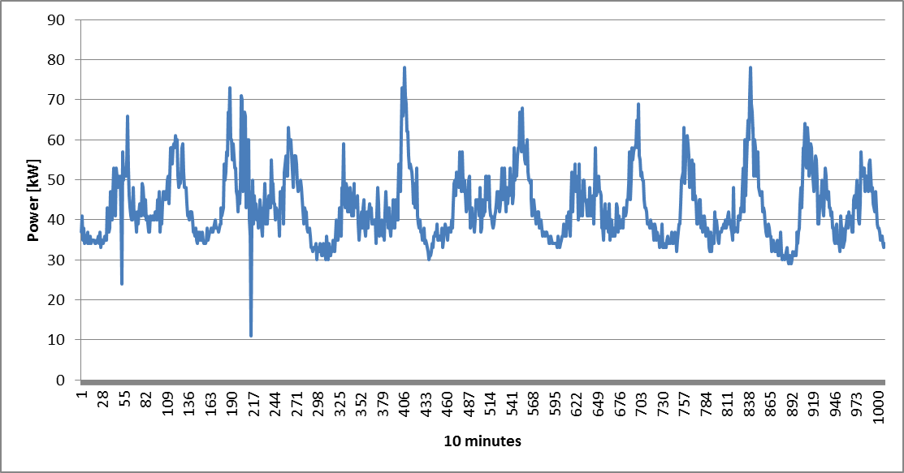
Figure 1: Weekly production profile of Atiu (14/10/13 to 20/10/13)
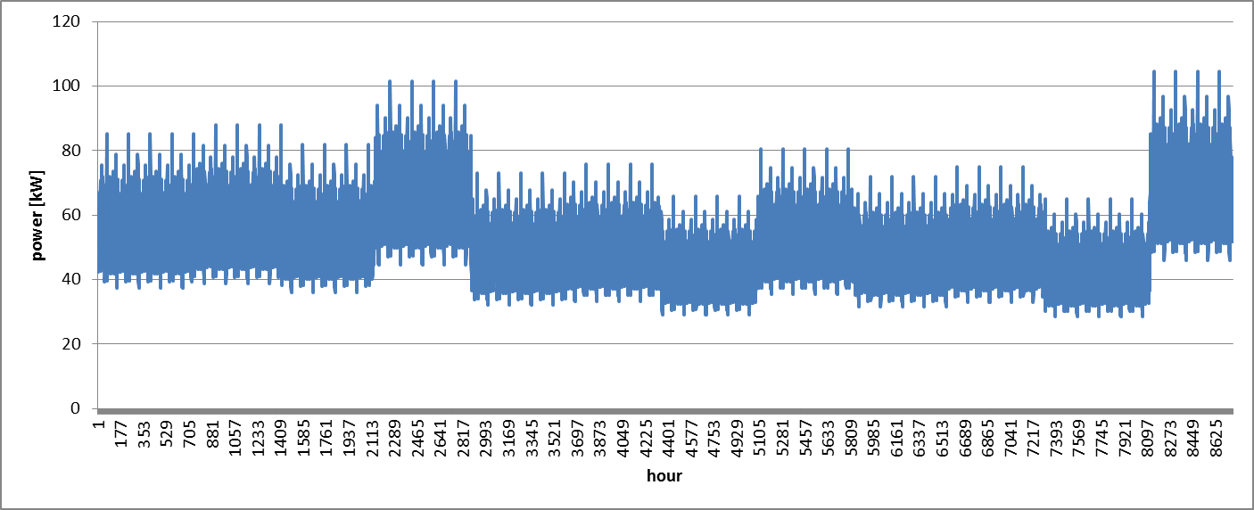
Figure 2: Synthetic annual production profile of Atiu
Demand projections are pretty conservative for Atiu. No significant construction projects are planned and almost all households are grid connected. It is therefore expected that the electricity demand remains stable for the next years.

PROJECT SITE 5: Aitutaki Island
Aitutaki, one of the Cook Islands’ medium-sized outer islands (pop. 2035), is a good candidate for a PV/diesel hybrid mini-grid to cover its electricity needs and to reduce Diesel fuel and non-renewable sources dependence. This is according to the New Zealand Ministry of Foreign Affairs and Trade’s (MFAT) Pacific Energy Program (PEP).
The island has ha particular touristic vocation, it's a very famous place for honeymoon travels and marriage travels. The territory for this reason is mainly occupied by residential users, resorts and hotels. The biggest loads are hospital, schools and waste management facility equipped by an aluminum can crunching machine, its power is not particularly high to affect grid stability. The tourism has shown a significant development in the last 10 years and approximately 50% of Aitutaki population is working in this sector.
The island has a power generating station with two different voltage feeders. It appears that the island council's desire is to renew the older one working at 3,3 kV and transform it into a 11 kV distribution system so to have a uniform distribution system. There are 650 residential and 100 commercial consumers. Domestic tariff is 0,89 $ per kWh for the first 1000 units and 0,65 $ above that limit, a rate that covers only a fraction of the production costs. These numbers are shown also on the official documents supplied by the government office, anyway two government publications show different price per kWh. It has been noted a 20 cents/kWh increase on the flat rate between the publication of February 28th 2012 and the publication of April 2012.
Power station show modern generators from Turkish supplier Aksa and control panels are managed by a computerized system that records production data and other relevant information. Also the control systems are in excellent conditions being installed recently.
The land offers sufficient space for installing a Photovoltaic system. There are land already publicly owned, closer to the power station. An additional option for suitable land is the old airport runway, this solution could offer a huge amount of cleared surface but the metallic structure will be exposed to salty fog due to the close proximity with the ocean.
Logistics: Aitutaki is the only minor island that can offer easy harbor landing facility. They currently land 20 feet containerized fuel tanks (Petrol and Diesel) thanks to a crane capable of lifting loads of more than 5 tons (weight limit for other minor islands). The container tanks can store up to 26000 liters each. This could give substantial advantages in this field.
Review of Existing Studies
According to a report of ADB dated March 2007 TA 4605-COO, Vol. 1 Master Plan, Aitutaki power supply is operated by a state-owned enterprise, Aitutaki Power Supply (APS), which has its own board of directors, and reports annually to the Board of CIIC on the management and status of assets. The existing genset comprises five units – three 40 kW and two 200 kW units. However, they are obsolete, unserviceable and in need of replacement. At present, as a temporary measure APS is using a hired 800 kW gensets from NZ Generator Hire. It is understood that APS intends to purchase similar units to the hired genset within the current fiscal year.

The same report mentions about renewable energy use on Rarotonga is mostly in the form of solar energy for hot water supply and it is commonly used by both households and commercial premises. There are proposals to install wind monitoring towers on Rarotonga and Aitutaki and there are plans for a wind power generation project currently managed by the Energy Division of MOW with technical assistance provided by the South Pacific Islands Applied Geoscience Commission (SOPAC). The project has not started as yet.

While on other islands this report talks about a need to improve the efficiency of operation of power stations, through appropriately upgrading the generation setup, and up-skilling of the staff involved with the management, operation and maintenance of the power station and associated facilities, this was not considered important for both Rarotonga and Aitutaki. So already in year 2007 the Aitutaki power generation system was already reputed efficient and in good conditions. The same reports includes in the “Suggested Projects in the Energy Sector – Short Term” the possibility and the need of replacing generators in Aitutaki with an expected 0.9M$ government’s own capital expenditure, already had funding approved and had pending the Fiscal Year 2006/07 budget release.

In the same report's table named “Summary of Suggested Projects in the Energy Sector - Medium Term” a high voltage electricity supply distribution system upgrade was mentioned for a total amount of 1,7 M$

In year 2012 Powersmart Solar submitted to Aitutaki power authority a solar plant proposal with a 303.6 kW size and for a total price of $1,038,500.00, capable of supplying an estimated 459,202 kWh per annum.
Assessment of Power Generation System
Diesel Gensets
The team found the Aitutaki power plant very well manage by the general manager Mr. Long (mailto:power@aitutaki.net.ck) and his staff. It is located in a modern concrete building between Vaipae and Arutanga on Crown Land adjacent to the Island Administration infrastructure yards.
Presently Aitutaki generates its electricity with a modern diesel power plant newly built in 2009 by Cummins. The system is 100% based on automotive diesel oil (ADO). The plant consists of three 656kW Cummins diesel generators of the type:

Internal Combustion Engine | QSK23
Alternator | C900D5
Controller | PCC3201

The gensets are controlled by a fully automated paralleling system of type:

Cummis DMC 200/4 (4x PCC3100/PCC3200).

The system controls the synchronizing and paralleling process of the diesel generator. It also logs all relevant data. A Windows-based PC is used to visualize the data.
- Operation mode
For most of the time the load is below 656kW and can be met by just one diesel generate alone. The biggest load was measured two years ago with 650kW. Today, the max. load does not exceed 580kW. The min. load is at 380kW.
Cummins has recommended bringing a second diesel generator online once the load reaches 80% of the nom. power of the genset, which is at 524kW. Sharing the load of 524kW by two gensets (2x 262kW) means the two operate at just about 40% of their nom. power. This is probably the lower limit at which the engine can be operated without the risk of damaging it. The operation below the min. power can cause cylinder glazing though should be avoided. Above 524kW it is possible to operate two genset in parallel and therefore ensure N-1 failure probability. This means in the event of the failure of one engine the other would take over the complete load and a blackout would be avoided.
Demand Side
The load of Aitutaki is dominated by hotel resorts and domestic customers. Additionally one hospital, schools and the waste management facility influence the load profile.
The energy consumption peaks during holiday times (December, January: Christmas; March, April: Easter) when the most tourists are on the island. The annual production of electricity is 3,600 MWh for Jul 2012 to June 2013. Monthly values are taken from the electricity reports.

Month | Gross Diesel Generation (kWh)
Jul-12 | 291,636
Aug-12 | 297,782
Sep-12 | 278,505
Oct-12 | 306,391
Nov-12 | 314,361
Dec-12 | 324,104
Jan-13 | 337,050
Feb-13 | 267,279
Mar-13 | 330,791
Apr-13 | 303,972
May-13 | 312,266
Jun-13 | 307,092
FY 2013 | 3,671,229

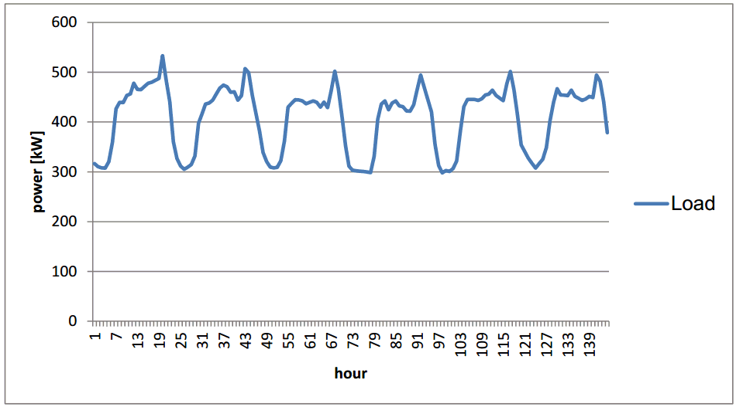
From the automatic data logging system at the power plant 10 minutes logs of electricity production are extracted for the week from the 16th to the 22nd of September 2013. These values have been taken to create an hourly load profile for one year by adjusting it to the monthly values of Figures 1 and 2, where the weekly and annual load profile (measured at the production site) of Aitutaki are shown.
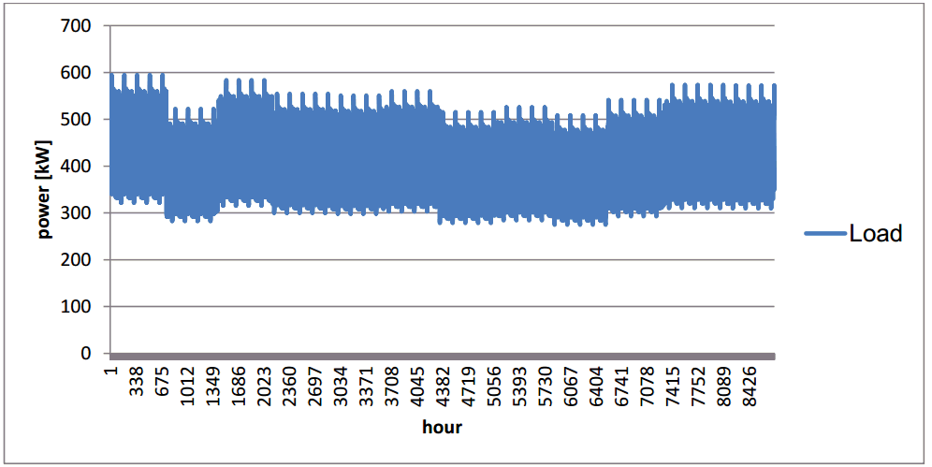
Figure 1: Weekly production profile of Aitutaki (09/16/13 to 09/22/13)

Figure 2: Synthetic annual production profile of Aitutaki

Demand projections are pretty conservative for Aitutaki. No significant construction projects are planned and almost all households are grid connected. It is therefore expected that the electricity demand remains stable for the next years.

